Censorship at AGU: scientists denied the right of reply

Has the Journal of Geophysical Research been coerced into defending the climate alarmist faith?

J. McLean, C.R. de Freitas, and R.M. Carter

“Having now read the paper [McLean et al., 2009] in a moment of peace and quiet, there are a few things to bear in mind. The authors of the original will have a right of reply, so need to ensure that they don't have anything to come back on.”

Phil Jones to Jim Salinger, July 28, 2009

“But as it is written, the current paper [Foster et al. draft critique] almost stoops to the level of "blog diatribe". The current paper does not read like a peer-reviewed journal article. The tone is sometimes dramatic and sometimes accusatory. It is inconsistent with the language one normally encounters in the objectively-based, peer-reviewed literature.”

Anonymous referee of the Foster et al. critique, September 28, 2009

“Incidentally i gave a copy [of the Foster et al. critique] to Mike McPhaden and discussed it with him last week when we were together at the OceanObs'09 conference. Mike is President of AGU. Basically this is an acceptance with a couple of suggestions for extras, and some suggestions for toning down the rhetoric. I had already tried that a bit. My reaction is that the main thing is to expedite this.”

Kevin Trenberth to Grant Foster, September 28, 2009

Preamble
Science is best progressed by open and free discussion in which all participants have equal rights of contribution. This is especially the case when a scientific issue is related to a matter of high public controversy - such as the hypothesis of dangerous human-caused global warming.

In July 2009 we published a paper in the peer-reviewed Journal of Geophysical Research (JGR) in which we described the results of comparing global atmospheric temperature since 1958 with variations in the El Nino-Southern Oscillation (ENSO) climatic framework. Our analysis supported earlier research that demonstrates a close link between these factors, and indicated that a large portion of the variability in global temperature is explained by ENSO variation, thus leaving little room for a substantial human influence on temperature.

On November 20, a newly appointed, replacement JGR editor informed us that a group of scientists led by Grant Foster had submitted a critique of our paper for publication in JGR. We were invited to write a response, which we did, submitting it to JGR on January 14, 2010.

On March 16, the replacement editor contacted us again. He included three referees’ reports, and indicated that on the advice of these referees he was rejecting our response to the Foster et al. critique, and that the response would therefore not be published in JGR.

The practice of editorial rejection of the authors’ response to criticism is unprecedented in our experience. It is surprising because it amounts to the editorial usurping of the right of authors to defend their paper and deprives readers from hearing all sides of a scientific discussion before they make up their own minds on an issue. It is declaring that the journal editor - or the reviewers to whom he defers - will decide if authors can defend papers that have already been positively reviewed and been published by that same journal. Such an attitude is the antithesis of productive scientific discussion.

Something smells, and a hint of what is on the wind is contained in the quotations at the head of this preamble.

To set the historical record straight, we relate below in date order the events – as they are known to us - that led to the editorial censorship of our reply to the critique by Foster et al.

Thereafter, we provide three appendices:

Appendix A – the Foster et al. critique of McLean et al., 2009, as posted on the web prior to its publication by AGU.

Appendix B - our (JGR-rejected) response to this critique.

Appendix C - a recent editorial commentary about AGU publishing practices by the President of the Union (which publishes JGR), Professor Timothy Grove.

The original research paper that is the subject of the critique (Appendix A) and the response (Appendix B) is:

McLean, J., de Freitas, C.R. & Carter, R.M., (2009) Influence of the Southern Oscillation on tropospheric temperature. Journal of Geophysical Research 114, D14104, doi:10.1029/2008JD011637.

It can be accessed at: http://www.agu.org/pubs/crossref/2009/2008JD011637.shtml.

John McLean, Chris de Freitas, Bob Carter
March 22, 2010
How not to conduct a fair and impartial scientific debate:
an itemised history of the AGU censorship

The following events occurred in relationship to a paper that we submitted for publication in the Journal of Geophysical Research on December 12, 2008, up until March 16, 2010, when the editor rejected our reply to criticism of our paper.

December 12, 2008. Initial submission of a paper by McLean, J., de Freitas, C.R. & Carter, R.M., titled “Influence of the Southern Oscillation on tropospheric temperature”, for consideration for publication in the Journal of Geophysical Research (JGR), Atmospheres.
February 17, 2009. The first JGR editor that we dealt with forwards reports from three referees and a request that the authors revise the paper according to criticisms made by the referees.
One referee commented in part: “I found the paper to be well-organized, well-written, and clear on the importance of the research. The abstract is informative, reference section is excellent, and the graphics are of high quality. The findings are likely to be of interest to a wide variety of readers.”
A second referee commented in part: “This very clear and well-written manuscript is an analysis of the relationship between MSU-derived and radiosonde-based tropospheric temperature variability and the Southern Oscillation, as modified by major tropical volcanic eruptions. I find few faults with this analysis from a scientific standpoint; my primary concern is the lack of novelty. Climatologists have known about the strong linkage between the SOI (and its cousins) and tropospheric temperature for some time now. The authors acknowledge as much and they include most of the key references on the subject.”
As well as these general comments, all three referees made constructive criticisms of various technical points, to which we responded by modifying our manuscript to take account of them.
March 24, 2009. After incorporating appropriate modifications in response to the referees’ criticisms, a revised and improved manuscript is submitted to the AGU.
April 27, 2009. The editor indicates acceptance of the revised paper for publication in a forthcoming issue of JGR Atmospheres.
July 23, 2009. Publication of the McLean et al. paper in JGR Atmospheres.
The paper first established that a 7-month time-lagged relationship exists between changes in ENSO and changes in average global lower tropospheric temperature, except when volcanic eruptions cause cooling, and then applied this time lag to raw data in the Discussion and Conclusions. The establishment of the 7-month time lag employed an unusual method, but the period was in general agreement with earlier papers by other authors, and our Discussion and Conclusions would have been essentially the same if we had sourced the time lag from one of those other papers. The relevance of this point will become clear later.
Important note. We note that up to this point, all persons involved – namely, the JGR editor, referees and authors - had behaved according to the normal professional code of conduct that applies to papers being processed for scientific publication, and in accordance with the sentiments expressed on this matter in a statement by AGU president Professor Timothy Groves (see Appendix C). Thereby, a paper had been submitted, refereed, modified according to the referees’ comments, accepted by the editor, and finally published.
However, these circumstances were about to change and for the details we turn to emails that have been released into the public domain by the Climategate affair, and to our emailed exchanges with the JGR editor.
The Climategate emails show that shortly after publication of the McLean et al. paper a group of IPCC-related climate scientists started to prepare a critique of the paper. Of course, as scientific authors we see nothing wrong with that per se – indeed we would normally welcome intelligent discussion and criticism of our work – but, disturbingly, the motivation of the IPCC group appears to have been to blunt the impact that the McLean et al. paper might have on the public view of dangerous human-caused global warming, and to prepare the way for ignoring or dismissing the paper in the forthcoming IPCC 5th Assessment Report. On this matter one email contains reference to another email in which Michael Mann writes:
“a formal comment to JGR seems like a worthwhile undertaking here. contrarians will continue to cite the paper regardless of whether or not its been rebutted, but for the purpose of future scientific assessments, its important that this be formally rebutted in the peer-reviewed literature.”
About August 3, 2009. The group of IPCC-related scientists (Grant Foster, James Annan, Phil Jones, Michael Mann, Jim Renwick, Jim Salinger, Gavin Schmidt and Kevin Trenberth; henceforth Foster et al.), having prepared a critique of McLean et al., posted it on the Internet– formatted in JGR style, as if it has already been accepted by JGR.
About August 3, 2009. At about the same time as posting it on the Internet, Foster et al. submit their critique to the editor of JGR Atmospheres.
Comment – editorial interference. Several Climategate emails, written in late July and early August, throw light on the attitudes of the Foster et al. authors as they concluded writing their critique, and the manner in which they approached its submission.
For example, Kevin Trenberth comments to the other authors that "Obviously the editor and reviewers need to to [sic] also be taken to task here." Another CRU email contains the proposed letter to the editor to accompany the critique when it is submitted, which asserts:
“We consider that the errors in the analysis of McLean et al are so serious that the publication of a Comment to correct the public record is amply justified. In view of the high profile of the issue, we would prefer if one of the senior editors could take charge of the editorial process.”
Two days later, in a third CRU email, we find that a new JGR editor has replaced the original editor (and we will refer to him as editor-2 from here on). Editor-2 at the time was also acting as the editor for a paper co-written by Jones that was in pre-publication in July.
Comment – recommendations re referees. AGU makes a standard request to authors asking them to suggest suitable reviewers for a submitted paper, viz: "Please list the names of 5 experts who are knowledgeable in your area and could give an unbiased review of your work. Please do not list colleagues who are close associates, collaborators, or family members."
In response to this request, the Foster et al. group suggested the following persons as possible reviewers for their submitted critique: Ben Santer, Dave Thompson, Dave Easterling, Tom Peterson, Neville Nicholls, and David Parker (with Tom Wigley, Tom Karl and Mike Wallace also mentioned but regarded as doubtful). Phil Jones commenting "All of them know the sorts of things to say - about our comment and the awful original, without any prompting."
A search of the Climategate emails for each of the names suggested above shows that all six of these persons were reasonably well known to Phil Jones, one of the authors of Foster et al., with whom contact had often been made with regards to co-authored papers. Tom Wigley was the head of the Climatic Research Unit at the University of East Anglia prior to Jones taking that position. Finally, another of the suggested reviewers, Neville Nicholls, mentioned our paper in an email to Jim Salinger, another co-author of Foster et al., on or prior to 29 September 2009, the day after editor-2 had emailed the reviewers' comments to the Foster et al. authors. These documented facts make it very clear that Foster et al. were confident that the potential reviewers they suggested would support their criticisms of McLean et al., which makes their nomination a blatant disregard of the AGU's request for unbiased reviewers.
Editor-2 was advised twice of the existence of Climategate emails that related to our paper (both times on 20 Nov 2009), but his first response was to dismiss them as irrelevant and he ignored our second comment.
August to November, 2009. The Foster et al. critique is sent out for review, the results of which are forwarded to the authors by editor-2. Foster et al. modify and resubmit their document.
November 20, 2009. Editor-2 informs McLean et al. that:

“Comments on your JGR-Atmospheres manuscript "Influence of the Southern Oscillation on tropospheric temperature" have been submitted by Foster et al. and have passed peer review. I invite you to submit a reply to the comments, which are attached. ...... Your reply will be reviewed and, if acceptable, will be published at the same time as the comments.”

November 21-26, 2009. John McLean and editor-2 exchange a number of emails regarding the improper posting of the Foster et al. critique on Kevin Trenberth’s website.

McLean to editor-2. “Are you aware that a draft of the Foster et al critique appeared on Kevin Trenberth's web pages less than 2 weeks after our paper was published and that this draft was formatted to look like a JGR paper? It included the JGR page header and even the AGU copyright notice and price at the foot of the first page.”

Editor-2 to McLean. “No, I was not aware of that. I have looked at it. It very clearly says submitted, but I will ask Kevin to remove it until it is accepted.”

McLean to editor-2. “It was only labelled "submitted" some time - 2 weeks or more - after it was posted. (I saved a copy of the draft that Kevin had posted and the date on that file is 7 August and it is not labelled "submitted".)”

Comment – the addition of the label “submitted” was probably in response to criticism that the Foster et al. group had received themselves, as indicated by the comment made by Mike Mann in an email to Grant Foster on August 7:

“a few folks have expressed concern that the galley-formatting of the article w/out any label such as "submitted to JGR" is a bit misleading. some people think the paper has already gone to press! we should add a clear label such as 'sub judice' or 'submitted' to any posted and/or circulating version of this".

In any event, the prior posting without this label was a clear breach of the AGU requirement that:

“AGU does not knowingly publish reports, letters, and articles that have been previously published and it expects authors at time of submission to state any previous public distribution of their work in electronic and printed formats. For the purposes of this policy statement, prior publication is defined as distribution of research in any form that constitutes public distribution, e. g., scientific journals, books, serials issued by a commercial publishing company, unclassified government documents, etc., that can be accessed in print and/or by electronic access. Specifically, any document that is accessible to a library user, who does not have special access or privileges, directly or indirectly by interlibrary loan, scanning and delivery by fax, email or other electronic means is considered published, except as noted below. Electronic posting of preprints to services that provide or purport to provide archiving with citation protocols and public retrieval capabilities also constitutes publication.”

According to these rules, it is beyond doubt that the Foster et al. paper had been “previously published”. The AGU's rules expect the authors to declare this at the time of submission, which would have caused automatic rejection of Foster et al. Editor-2 argued in an email to us that prepublication on the Internet was permitted according to an AGU web page about copyright. That page stipulated that the document was not to be formatted (presumably in JGR style), but it was. Despite at least one breach of AGU protocols and possibly two, the Foster et al. comment has now been accepted by editor-2 for re-publication in JGR Atmospheres.

January 15, 2010. Submission by McLean et al. to JGR of their response to the criticisms of Foster et al., in the format required and within the time period allowed.
Our response (see Appendix B) pointed out that most of the criticisms by Foster et al. were misdirected, including in particular their inaccurate characterisation of our statistical protocol. Foster et al. claimed that we used a technique that filtered data, and then made our key statements on the basis of that filtered data. In actuality, we used the filtering technique solely to establish that a 7-month time lag existed between changes in the ENSO and changes in global average lower tropospheric temperature, which was a non-controversial finding that accords with earlier research (e.g., by Phil Jones, who is one of the co-authors of the Foster et al. comment). Our substantive conclusions were then based on applying this time-lagged relationship to the raw data sets, for which purposes the methodology by which we had established the time lag are irrelevant.
Valid scientific criticism of our findings would require a demonstration that the time-lagged relationship we used was incorrect, but only after making allowances, as we did, for ad hoc cooling caused by volcanic eruptions and temperature variations caused by short-term weather events. Foster et al. made no attempt to discuss these matters, but focused only on the method by which we had determined - or arguably reconfirmed - the time lag of 7 months.

March 16, 2010. Editor-2 returns the McLean et al. response, together with three negative reviews from three referees and the comment:

“I therefore regret to inform you that based on the Reviewers' recommendations, I am unable to accept your paper for publication in JGR-Atmospheres.

Please note that the reviewers are highly respected members of the scientific community. I consider their reviews to be unbiased assessments of the the [sic] scientific validity of your response.”
Final Comments. It is unclear why the editor sent our response to Foster et al. out for review, because it almost entirely restates material that was included in the original paper. That original paper received positive reviews from its three reviewers, but our response to the comments, although largely restating the Discussion and Conclusions of the original paper, received three negative reviews.
It seems hardly likely that the three reviewers of our original paper would alter their opinions so radically unless under great pressure, so we therefore assume that three new reviewers were engaged for our comment paper. We ponder if among these three were one or more of the people whose nomination by Foster et al was predicated on their anticipated bias. We accept that editor-2 may have regarded those people as "highly respected members of the scientific community". We also cannot dismiss the possibility that editor-2 may have engaged reviewers whom he expected to be less than impartial, because his prior failure to disqualify, or at least censure, the Foster et al. comment for breaches of AGU rules suggests that his own actions were also less than impartial.
In addition, most of the reviewers’ comments on our response were aimed more at the original paper than at the limited technical matters raised by the critique and our response, for example:
“... they certainly did not go out of their way to make it clear to the reader that their conclusions and interpretations applied only to these derivatives and not to the unfiltered SOI and temperature series ....” [Our response was very clear on this (see Appendix B), so the comment can only apply to the original paper]
“How in the heck did the original dog of a paper ever get through the review process. Please check it out and reprimand the appropriate editor.”
In his explanation of the standards AGU expects of editors and reviewers (Appendix C), AGU President Timothy Grove asserts that reviewers are expected to "evaluate the quality of the science based on specific criteria related to whether or not the scientific evidence supports the conclusions of the paper".
Yet the three reviews of our response that we were provided with were scientifically insubstantial. Only one reviewer mentioned the time lag that we established, despite its pivotal importance to our findings. And two reviewers focussed mainly on the derivative technique that Foster et al.'s comment falsely implied was the basis of our conclusions.
In his email to us in which he announced his decision against publishing our response, editor-2 said, "All of the Reviewers raise very serious objections and recommend against publication”. It is apparent from this, and from the related matters discussed above, that the JGR editorial process is unable to distinguish between reviewers' comments that are trivial or irrelevant (whether deliberately so or otherwise), and comments that properly focus on whether the discussion and conclusions of a paper are supported by scientific evidence. In essence, current JGR procedures fail to discriminate whether a submitted comment relates to a substantive or to a peripheral issue.
Editor-2, and the reviewers to whom he deferred, also failed to observe the incorrectness of the allegation by Foster et al. that our paper said that the ENSO could not be simulated, when in fact we quoted the section of the IPCC's 2007 report that claims "considerable modelling skill out to 12 months for ENSO prediction", which implies poor modelling skill beyond that period.
Summary
The history of events outlined above demonstrates scientific malfeasance in the following ways:
- Collaboration to attack scientific papers that provide evidence militating against a dangerous human influence on climate, by a group of scientists whose attitudes have already been exposed by the CRU email (a.k.a. Climategate) affair, namely Grant Foster, James Annan, Phil Jones, Michael Mann, Jim Renwick, Jim Salinger, Gavin Schmidt and Kevin Trenberth.
- The clear intention of this group has been to try to damage the credibility of an independently refereed paper whose conclusions they disliked, rather than to create and participate in a constructive scientific discussion amongst equals.
- Inappropriate contact between one of the authors (Kevin Trenberth) and the former President of the AGU (Mike McPhaden), in a way that can be construed as interference in editorial process.
- Inappropriate tampering with AGU editorial management by requesting an alternative editor, which resulted in the replacement of the original editor by editor-2.
- Unprofessional publication of Foster et al.’s critique on the Internet, in AGU journal format, before it had been considered or accepted for publication by AGU.
- Questionable editorial inaction, in editor-2 not rejecting the Foster et al. critique on grounds of its prior publication and formatting, both in direct contravention of AGU guidelines.
- Failure to follow the AGU guidelines regarding nomination of potential reviewers, by Foster et al. proposing persons (a) with whom they have close professional relationships and (b) in anticipation that they will be biased.
- Error of editorial judgement in accepting for publication a critique of a paper that contains incorrect claims about the content of that paper and focuses on peripheral issues rather than on the paper's substantive scientific conclusions.
- Failure to apply editorial power impartially, but instead acting in support of the prevailing hypothesis of dangerous human-caused global warming.
- Denial of a right of reply to those whose research was being criticized.
The AGU is a leading American and international professional organisation concerned with the earth sciences. It is therefore not surprising that, on an earlier occasion when it was criticized for inadequate editorial standards, the AGU President responded with the statement that (Appendix C):
“AGU is, and always has been, firmly committed to maintaining the highest standards of publishing excellence, including the objectivity and integrity of the peer review process for all its publications. We do not censor the authors of papers submitted to our journals or the editors of those journals. In the area of climate research, AGU will continue to publish excellent, peer-reviewed scientific findings regardless of whether they appear to support or question prevailing theories.”
We leave it to readers to judge whether, in handling the events described in this paper, the AGU has lived up these self-proclaimed standards.
Conclusions
Peer-review is a far from foolproof method of scientific editorial quality control, but it is nonetheless probably the best system available. Provided, that is, that an editor selects competent and dispassionate referees, pays attention to what they advise and exercises sound judgement as to whether the critical comments are relevant to the scientific issues at the heart of the paper.
In handling the critique of our paper, the AGU, through its editorial practices, appears to have failed to conform to its claimed publication principles and practices (Appendix C), and, in a flagrant breach of normal scientific procedure, has denied competent scientists the right of reply to criticism of their research. As a result, AGU editor-2 is now allowing irrelevant and quite misleading criticism to be re-published unrebutted, having relied upon the advice of partial reviewers who completely ignored the key question as to whether the evidence presented in the McLean et al. paper supported the conclusions that the authors drew.
We are left with the unanswered question as to whether this situation has arisen from editorial ineptitude at the JGR, or whether the journal, in avoiding publishing our reply, was responding to coercive pressure from influential supporters of the speculative hypothesis of dangerous human-induced climate change.

APPENDIX A

Critique by Foster et al., as published on the Internet in early August 2009
(http://www.cgd.ucar.edu/cas/Trenberth/trenberth.papers/Foster_et_alJG09_formatted.pdf)

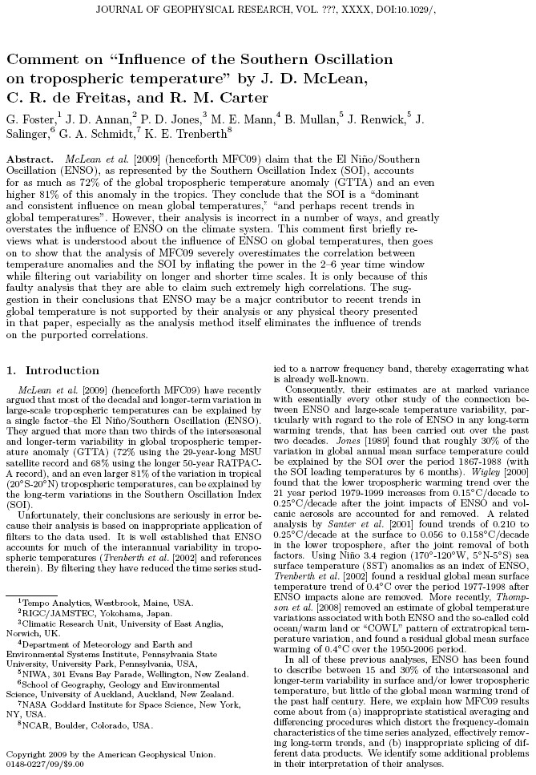

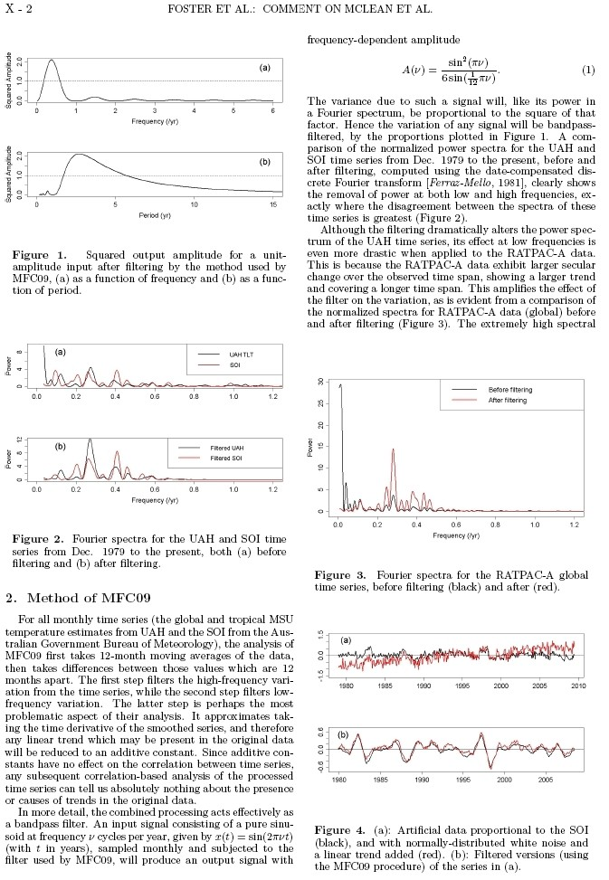

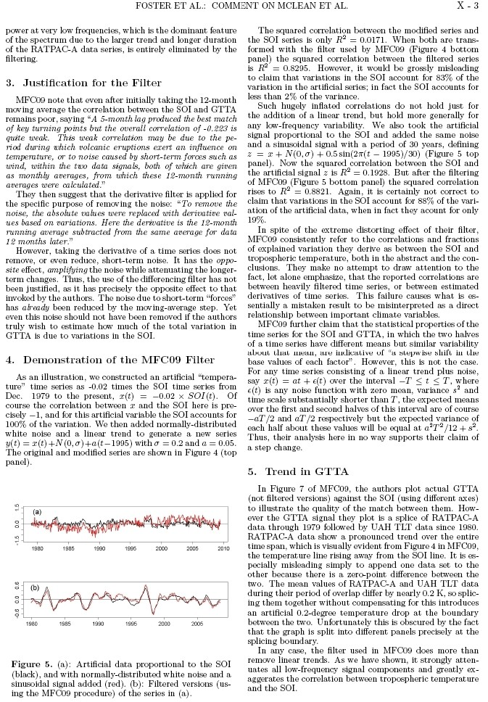

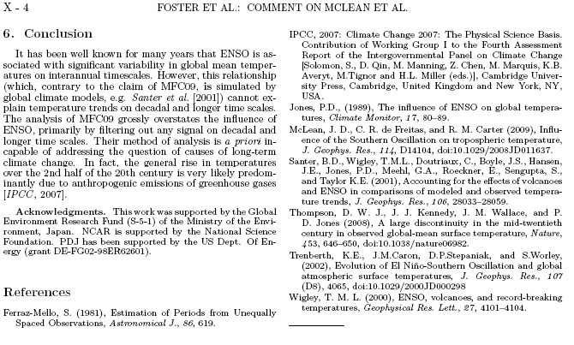

APPENDIX B
Response to “Comment on ‘Influence of the Southern Oscillation on tropospheric temperature’” by Foster et al.
J. D McLean¹, C.R. de Freitas^{2*} and R.M. Carter³

¹ Applied Science Consultants, P.O. Box 314, Croydon, 3136, Australia
² School of Environment, The University of Auckland, New Zealand
³ Marine Geophysical Laboratory, James Cook University, Queensland, Australia

* Corresponding Author: c.defreitas@auckland.ac.nz
Abstract
Key data presented in McLean at al (2009a) show that the Southern Oscillation is a dominant and consistent influence on mean global temperature and, contrary to what Foster et al. (2010) imply, the data in question (Figure 7) were not subjected to contrived statistical analysis. We explain that there are natural mechanisms that might account for the strong coherence of Southern Oscillation Index and mean global temperature. Our research did not set out to analyse trends in mean global temperature, but, should any such trend exist, it follows from our analysis that in most part it would be a response to the natural climate mechanisms that underlie the Southern Oscillation. We believe the findings of our work are important and reinforce similar conclusions from previous research using other datasets. We therefore stand by the analysis and conclusions of our paper.
Text
We thank Foster et al. (2010) (hereafter Fea10) for their discussion of our paper, and, subject to appropriate caveats, we agree with several of their remarks.
Fea10 state that the method of derivatives that we employed would minimize long-term trends. We completely agree, and wish to stress that we used derivatives only to ascertain the existence of the relatively consistent time-lag that exists between changes in the El Niño-Southern Oscillation (ENSO) and later changes in the global average lower tropospheric temperature anomaly (GTTA). Having demonstrated that a lagged relationship exists between changes in the Troup SOI and the lower tropospheric temperatures (LTT) data from satellite microwave sensing units (MSU LTT), we then investigated whether this was a chance artefact of the data by testing (successfully) for a corresponding relationship between the Troup SOI and radiosonde data (RATPAC-A LTT), and the Troup SOI and Tropical MSU LTT.
Our comments about the change in Southern Oscillation Index (SOI) accounting for 72% of the variance in satellite (MSU) GTAA, 68% of variance in the radiosonde (RATPAC-A) GTAA and 81% of variance in the tropospheric temperature in the tropics were made in the context of the discussion of our derivatives based on differentials between 12 month averages, and we stand by them. Contrary to Fea10 claims, those figures do not refer to long-term variations but only to the derivatives that were used. Further, the percentage that we attribute in each case would probably be higher if the data for the additional volcanoes that we tentatively identified in our Figure 7 were excluded in similar fashion to those data which we explicitly removed.
Using the Troup method, we determined a 7-month lag when using the SOI and the MSU LTT, a 6-month lag with the coarser RATPAC-A temperature data obtained via radiosondes, and a 5-month lag with the tropical component of MSU LTT only. It is surprising that Fea10 find fault with these figures when the two papers that they cite, namely Jones (1989) and Wigley (2000), are actually in good agreement with our findings. The former determined a 6-month lag between SOI and temperature and the latter refers to a 7-month lag, although both papers were based on the mean surface temperature dataset rather than the LTT that we used.
In their conclusion, Fea10 claim that we asserted that the relationship between temperature and ENSO could not be simulated. We made no such statement, and referred only to the view expressed in the IPCC's Fourth Assessment Report (IPCC, 2007, p. 627) that models of the ENSO system can provide acceptable predictions only to about 12 months ahead. Other deficiencies in ENSO modelling are discussed in the IPCC report (IPCC, 2007, pp. 623-625) and several recent papers, among them Halide and Ridd (2007), Chen and Cane (2008), Jin et al. (2008), Wu et al. (2009) and Kirtman and Min (2009). One co-author of Fea10, Trenberth, concurs with our judgment on the matter, having recently written: "It is not controversial to state that climate models are deficient in terms of tropical variability in the atmosphere on many timescales ... and a more realistic simulation of ENSO events in coupled simulations remains a high priority for model developers." (Trenberth et al., 2010, p. 11).
Fea10 went on to cite Santer et al. (2001) as an example of successful modeling of the relationship. Their paper uses a combination of an SOI calculated by unspecified methods (and possibly smoothed over some undefined period), and an SOI produced by modelling. It also used estimates of ENSO and volcanic signals that are apparently smoothed, and the MSU LTT as it existed prior to various later corrections. It makes no mention of the important time-lag that we and others have identified. For these reasons we regard the conclusions of this paper as speculative and only marginally relevant.
The reliance on models and estimates by Santer et al. (2001) require ad hoc assumptions to be made. Recognizing this, we deliberately confined our paper to the analysis of empirical data and explicitly omitted data for periods when temperatures were clearly influenced by volcanic eruptions because this influence is variable and can only be estimated.
The key to the findings of our paper is Figure 7, which shows the robust nature of the 7-month time-lag that we identified. In the light of criticisms by Fea10 about the use of derivatives, it is worth emphasizing that Figure 7 presents the data in its original form; namely, data that is not detrended, but with a time shift in SOI that has been determined from the detrended data. The primary temperature focus of our paper was the MSU LTT and therefore it features in this figure. Because we discussed RATPAC-A data for the years prior to LTT becoming available, a plot of the SOI and RATPAC data for that period is also included, not spliced or appended as Fea10 claim but as a separate graph, with different axis scales and different data granularity, as is evident from the visual nature of the graph.
The key portions of Figure 7 are parts (b) and (c), which are graphs of SOI and MSU LTT during two contiguous periods (McLean et al., 2009b). It is very noticeable in these graphs that the time-lagged relationship is consistent if allowances are made for ad hoc cooling caused by known

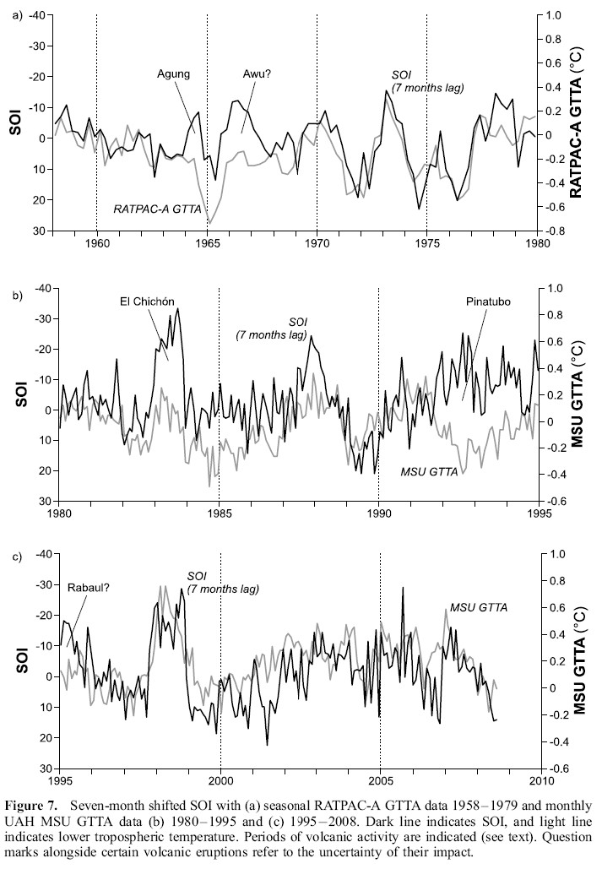
Figure from McLean et al., 2009
volcanic eruptions, for the typical short-term variability in monthly average temperatures, attributable to factors such as warm and cold air dispersion, cloud and precipitation, and for short-term variability in air pressures at Darwin and Tahiti from which the SOI is calculated. Despite such short-term variability, the cohesion of the curves in Figure 7(c) in particular is remarkable.
Figures 7(b) and (c) show that global average lower tropospheric temperature anomalies for the last 50 years have fallen and risen in close accord with the SOI of 5–7 months earlier, except during periods of cooling caused by volcanic eruptions, and reveals the potential of natural forcing mechanisms to account for most of the temperature variation during this time. This conclusion also implies that a high frequency of occurrence of El Niño conditions will cause a relatively sustained period of elevated temperatures, such as might popularly be termed ‘global warming’, whereas a high frequency of occurrence of La Niña conditions might be termed ‘global cooling’.
Well-documented physical processes can account for the relationship between ENSO and lower tropospheric temperature. Changes in Hadley and Walker circulation affect heat flow from ocean to atmosphere in a large zone over the Earth’s surface subjected to year-round strong solar forcing. During La Niña conditions, the zonal circulation of the Walker Circulation is enhanced with well-defined and vigorous rising and sinking branches, whereas the meridional circulation of the Hadley cell in both hemispheres weakens (Bhaskaran and Mullan, 2003). In contrast, during El Niño conditions there is an increase in Hadley circulation and subtropical highs intensify, although the relationship between the enhanced regional Hadley cell and warm-phase ENSO cycle circulation anomalies is not always straightforward (Bhaskaran and Mullan, 2003).
A more vigorous overturning of the Hadley circulation leads to an increase in heat transfer from tropical to higher latitudes in both hemispheres (Oort and Yienger, 1996, Trenberth et al., 2010) and plays a key role in the general circulation of the atmosphere. As meridional circulation increases during El Nino conditions numerous teleconnections occur (e.g. Indeje et al. (2000), Janicot et al. (2001), Ntale and Gan (2004), and Giannini et al. (2001)). A final but important consideration is that the suggested mechanism involves more than simply moving heat around within the global Earth-atmospheric system. Changes in ENSO affect convection, and thus atmospheric moisture content and cloud cover, which may in turn affect net solar heating as well as the transfer of heat from Earth to space Emile-Geay et al. (2007).
These teleconnections, shifts in circulation and changes in convection, with their consequent widespread influences on temperatures, can explain the correlation between the ENSO signal and MSU LTT as well as explain why other mechanisms, such as those related to human-caused greenhouse gas emissions, have only a minor influence compared to the variation in ENSO (Compo and Sardeshmukh, 2009). This last point is evident from our Figures 7(b) and (c) because if the sustained increases in the concentration of atmospheric carbon dioxide have a significant influence on temperature we would expect to see the temperature graph line consistently rising relative to the SOI graph line. The absence of this divergence implies, contrary to the claims of Fea10 and IPCC (2007) to which they refer, that increases in atmospheric carbon dioxide since the mid-twentieth century have had a negligible impact on global temperature.
The IPCC Fourth Assessment Report (IPCC, 2007) also agrees with our finding of a relationship between ENSO and global temperature (e.g., pp. 237, 238, 240, 245, 287, 288), although the report discusses only the warming influence of El Nino events in relation to near-surface temperature data (rather than lower tropospheric temperatures), appears to ignore the cooling influence of La Nina events altogether and briefly mentions a time-lag of just 1 month.
In summary, data presented in our paper (Figure 7) clearly show that the Southern Oscillation is a dominant and consistent influence on mean global temperature and, contrary to what Fea10 repeatedly imply, the data in question were not the product of contrived statistical analysis. There are natural mechanisms that might explain the observed strong coherence of SOI and global temperature. Our research did not set out to analyse trends in mean global temperature, but if any such trend exists, it must be linked in most part to natural mechanisms that underlie the Southern Oscillation. We believe that the findings of our work are important, and reinforce similar conclusions from previous research using other datasets. We therefore stand by the analysis and conclusions of our paper.
References
Bhaskaran, B. and A.B. Mullan (2003), El Niño-related variations in the southern Pacific atmospheric circulation: model versus observations, Climate Dynamics, 20, 229-239.
Chen, D. and M.A. Cane (2008), El Nino prediction and predictability, Journal of Computational Physics, Issue 7, 20 Mar 2008, pp 3625-3640, DOI: 10.1016/j.jcp.2007.05.014
Compo, G.P. and D.D. Sardeshmukh (2009), Oceanic influences on recent continental warming, Climate Dynamics, 32:333–342. DOI: 10.1007/s00382-008-0448-9
Emile-Geay, J., M. Cane, R. Seager, A. Kaplan, and P. Almasi (2007), El Niño as a mediator of the solar influence on climate, Paleoceanography, 22, PA3210, doi: 10.1029/2006PA001304
Foster, G., J. D. Annan, P. D. Jones, M. E. Mann, B. Mullan, J. Renwick, J. Salinger, G. A. Schmidt, K. E. Trenberth (2010), Comment on “Influence of the Southern Oscillation on tropospheric temperature" by J. D. McLean, C. R. de Freitas, and R. M. Carter, Journal of Geophysical Research, in press.
Giannini, A, J.C.H, Chiang, M.A. Cane, Y. Kushnir and R. Seager (2001), The ENSO teleconnection to the Tropical Atlantic Ocean: Contributions of the remote and local SSTs to rainfall variability in the Tropical Americas, Journal of Climate, 14, 4530-4544
Halide,H. and P. Ridd (2007), Complicated ENSO models do not significantly outperform very simple ENSO models, International Journal of Climatology, DOI: 10.1002/joc.1519
Indeje, M., H.M. Semazzi and L.J. Ogallo (2000), ENSO signals in East African rainfall seasons. International Journal of Climatology, 20, 19-46.
IPCC, 2007: Climate Change 2007: The Physical Science Basis. Contribution of Working Group I to the Fourth Assessment Report of the Intergovernmental Panel on Climate Change [Solomon, S., D. Qin, M. Manning, Z. Chen, M. Marquis, K.B. Averyt, M.Tignor and H.L. Miller (eds.)], Cambridge University Press, Cambridge, United Kingdom and New York, NY, USA.
Janicot, S., S. Trzaska and I. Poccard (2001), Summer Sahel-ENSO Teleconnections and decadal time scale SST Variations. Climate Dynamics, 18, 3003-320
Jin et al. (2008), Current status of ENSO prediction skill in coupled ocean-atmosphere models, Climate Dynamics, 31:647-664
Jones, P.D., (1989), The inﬂuence of ENSO on global temperatures, Climate Monitor, 17, 80-89
Kirtman, B.P. and Min (2009), Multimodel ensemble ENSO Prediction with CCSM and CFS, Monthly Weather Review, v.137, 2908-2930, DOI: 10.1175/2009MWR2672.1
McLean, J. D., C. R. de Freitas, and R. M. Carter (2009a), Influence of the Southern Oscillation on tropospheric temperature, Journal of Geophysical Research, 114, D14104, doi:10.1029/2008JD011637.
McLean, J. D., C. R. de Freitas, and R. M. Carter (2009b), Correction to ‘‘Influence of the Southern Oscillation on tropospheric temperature’’, Journal of Geophysical Research, 114, D20101, doi:10.1029/2009JD013006.
Ntale, H.K. and T.Y. Gan (2004), East African Rainfall Anomaly Patterns in Association with El Niño/Southern Oscillation, Journal of Hydrologic Engineering, 9 (4), 257-268.
Oort, A.H. and J.J Yienger (1996), Observed interannual variability in the Hadley Circulation and its connection to ENSO, Journal of Climate, 9, 2751-2767.
Santer, B.D., T.M.L. Wigley, C. Doutriaux, J.S. Boyle, J.E. Hansen, P.D. Jones, G.A. Meehl, E. Roeckner, S. Sengupta and K.E. Taylor K.E. (2001), Accounting for the effects of volcanoes and ENSO in comparisons of modeled and observed temperature trends, J. Geophys. Res., 106, 28033–28059.
Trenberth, K.E., J.T. Fasullo, C. O'Dell and T. Wong (2010), Relationships between tropical sea surface temperature and top-of-atmosphere radiation, Geophys. Res. Lett., doi; 10.10129/2009GL041466, in press
Wigley, T. M. L. (2000), ENSO, volcanoes, and record-breaking temperatures, Geophys. Res. Lett., 27, 4101–4104.
Wu, R., B.P. Kirtman and H. van den Dool (2009) - An Analysis of ENSO Prediction Skill in the CFS Retrospective Forecasts, Journal of Climate, vol 22, pp 1801-1818, DOI: 10.1175/2008JCL12565.1.

APPENDIX C

A Message from AGU's President

AGU Statement on Peer Review and Scientific Publishing

In his op-ed piece titled “How to Manufacture a Climate Consensus” (Wall Street Journal, 17 December 2009), Patrick Michaels called into question the integrity of the scientific review process in a scholarly journal published by the American Geophysical Union (AGU). As president of AGU, I want to set the record straight: Michaels' insinuations about AGU publishing and his premise that the peer review process can be systemically manipulated are not supported by the facts.
Hacked e-mails stolen from computers at the Climate Research United of the University of East Anglia showed several highly respected mainstream climate scientists grousing about an associate editor of AGU's journal Geophysical Research Letters (GRL) because of an article he published. In a stunning leap of bad faith, Michaels implies that the editor left his position a year after publishing the controversial article because those scientists somehow succeeded in getting rid of him. Michaels then represents this as evidence of a small number of individuals successfully controlling the peer review process over a period of years.
The facts in this case are that James Saiers of Yale University simply rotated out of his GRL associate editorship on schedule at the end of his three-year term. He was not forced out. Prior to his term as GRL associate editor for hydrology and biogeosciences, Saiers was associate editor of another AGU journal, Water Resources Research. He has held this post again since 2007.
Michaels paints a very unrealistic picture of how the peer review process works at AGU. The facts are that scientific manuscripts are sent to an editor who then distributes them to a set of qualified reviewers. These reviewers evaluate the quality of the science based on specific criteria related to whether or not the scientific evidence supports the conclusions of the paper. The editor considers the evaluations of the peer reviewers and then makes the final decision regarding publication of the paper.
All of the highly respected scientists who serve as AGU editors are charged with giving unbiased consideration to manuscripts offered for publication. They are required to be independent-minded and even-handed. They are also expected to attract innovative, high quality science that has the potential to open up new avenues of research.
Who are these editors? They are experts in their fields who volunteer or are nominated to serve by their peers. A search committee reviews applications, conducts interviews, and makes selections based on candidates’ scientific, editorial, and managerial qualifications. Final appointments are made by the president of AGU.
AGU is, and always has been, firmly committed to maintaining the highest standards of publishing excellence, including the objectivity and integrity of the peer review process for all its publications. We do not censor the authors of papers submitted to our journals or the editors of those journals. In the area of climate research, AGU will continue to publish excellent, peer-reviewed scientific findings regardless of whether they appear to support or question prevailing theories.
From the broader perspective of scientific publishing in general, history shows that Michaels' premise that a few scientists could skew peer reviewed literature toward a particular bias is false. The first American peer-reviewed journal, Proceedings of the American Philosophical Society, was published in 1838. Since that time the peer review system has successfully supported scientific advancement over a period of 170 years. Much research has been published on the peer review process itself, verifying time and again that it works.
Disagreement among scientists is part of the energy that moves inquiry forward. By encouraging and publishing the full range of well researched and well reasoned viewpoints, scientific publishing becomes self-policing. Over time the best science prevails.
Michaels' op-ed reflects a political strategy to sway popular opinion without regard for facts or the enormous body of scientific evidence that has accumulated with respect to climate change. The point is to get one's opinion, backed by whatever dubious evidence one can muster, published in highly influential publications such as the Wall Street Journal where it will be taken as some form of “truth.” Once that is accomplished, facts and informed opinion are lost in a windstorm of controversy — exactly as the author intended.
Sadly, recent polls indicate this strategy is succeeding relative to climate change research. The result is damaging to the entire scientific community and is a disservice to the public.

Timothy L. Grove
President-American Geophysical Union
Professor-Department of Earth, Atmospheric, and Planetary Sciences, MIT

Plus errata to figure label and caption. - McLean, J. D., C. R. de Freitas, and R. M. Carter (2009), correction to ‘‘Influence of the Southern Oscillation on tropospheric temperature,’’ J. Geophys. Res., 114, D20101, doi:10.1029/2009JD013006.
http://www.eastangliaemails.com/emails.php?eid=988&filename=1248790545.txt
http://www.cgd.ucar.edu/cas/Trenberth/trenberth.papers/Foster_et_alJG09_formatted.pdf
http://www.eastangliaemails.com/emails.php?eid=990&filename=1248877389.txt
http://www.eastangliaemails.com/emails.php?eid=1002&filename=1249326482.txt
http://www.eastangliaemails.com/emails.php?eid=1005&filename=1249655311.txt
http://www.eastangliaemails.com/emails.php?eid=1003&filename=1249503274.txt
http://www.eastangliaemails.com/emails.php?eid=1003&filename=1249503274.txt
http://www.eastangliaemails.com/emails.php?eid=1023&filename=1254232855.txt
http://www.eastangliaemails.com/emails.php?eid=1005&filename=1249655311.txt
http://www.agu.org/pubs/policies/dualpub_policy.shtml
http://www.agu.org/pubs/copyright.shtml
http://www.agu.org/about/presidents_msg/index.shtml Text of Letter to the Editor Submitted to and Published by the Wall Street Journal, Saturday/Sunday, 9-10 January 2010.

