More Examples Showing Recent Warming Exaggerated
By Joseph D’Aleo, CCM

Last year, Bruce Hall plotted monthly heat and cold records for the 50 states. The 1930s showed up as by far the record decade over the last century.

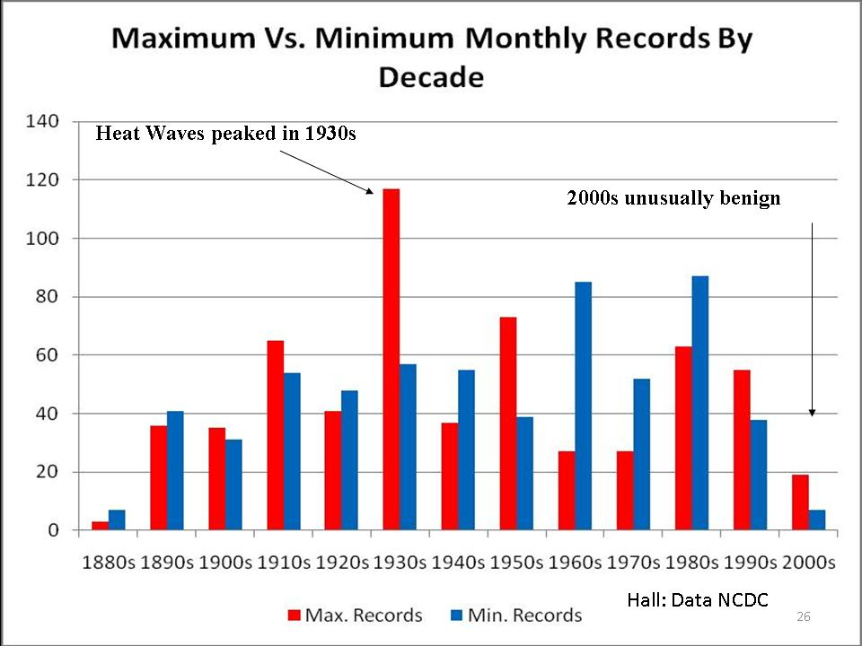

This was in sharp contrast to the claims by NOAA, NCAR, the EPA and IPCC which all claimed the heat records were increasing at an alarming or accelerating rate.

We looked at Des Moines, Iowa, a continental climate that should reflect the heat more than coastal areas. We looked at the daily records in June and July. Again it was the 1930s that showed up as the clear winner. 1988 was a hot La Nina summer (similar to this year following an El Nino. It had 5 record highs. There have been no records after 1988.

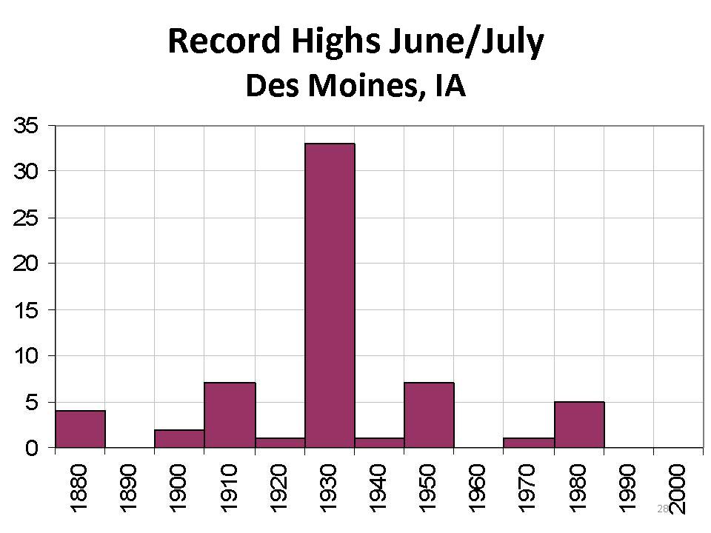
This morning I did a radio interview in Detroit. In preparation, I looked at record highs during the summer months of June, July and August. Again 1930s was the clear winner with 30 record highs. The warm era from the 1930s to the early 1950s had two and a half times the number of record highs the last three decades. Only two records were set this decade (2006).

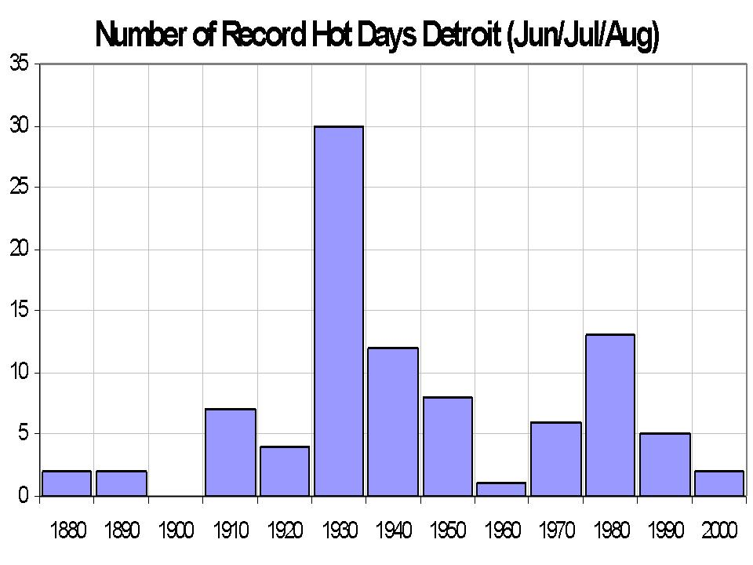
Though this summer has been a warm summer and may end up in the top ten warmest for Detroit, there have been no record heat days so far. There were 10 days with 90F temperatures in June and 2 this August. August was the warmest of the three summer months, mainly due to higher minimums due to more clouds and higher dewpoints thanks to moisture from air flowing over very wet grounds in WI and IA.

It has been indeed hot in the east and south central. But that was expected. It happens reliably when La Nina follows El Nino winters (1999, 1995, 1988, 1966) or after a El Nino with super blocking like this year (1977).

The heat in the east was intense in July but Dr Richard Keen showed how there is no trend in highest annual temperatures in Philadelphia since 1873.

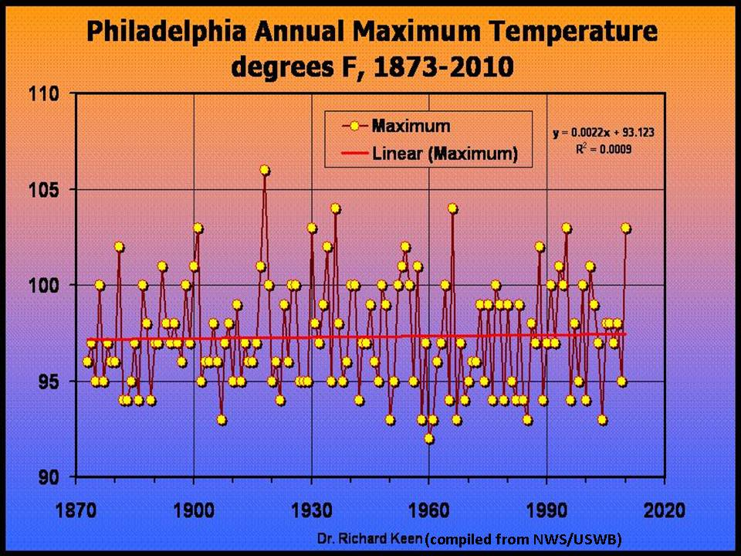

Back in 1999, when NOAA still was an honest broker about US temperatures, the USHCN temperatures looked like this.

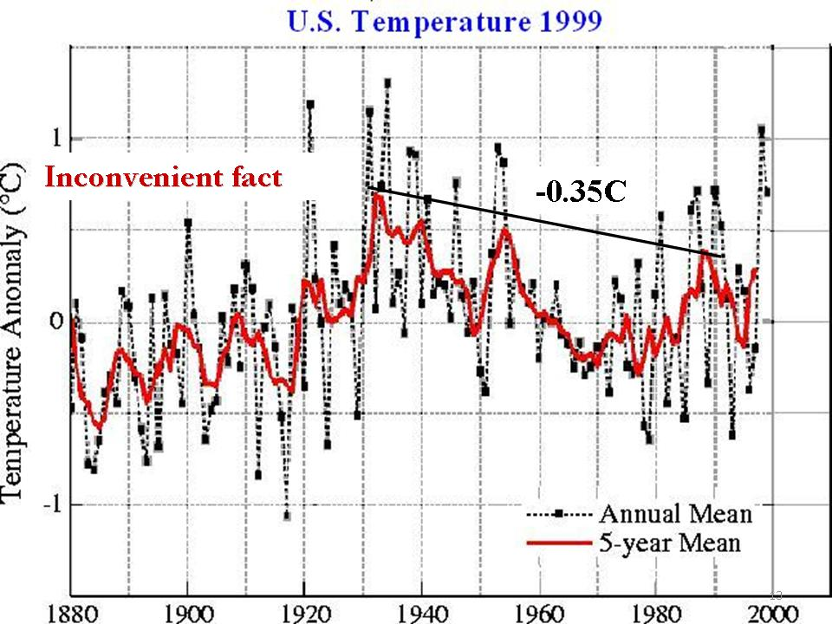

James Hansen of NASA remarked about this data then: “The U.S. has warmed during the past century, but the warming hardly exceeds year-to-year variability. Indeed, in the U.S. the warmest decade was the 1930s and the warmest year was 1934.”

It showed the peak in the 1930s to 1940 was higher than the late century warmth. NOAA removed the urbanization adjustment in 2007 and suddenly the warmest decades became the recent ones.

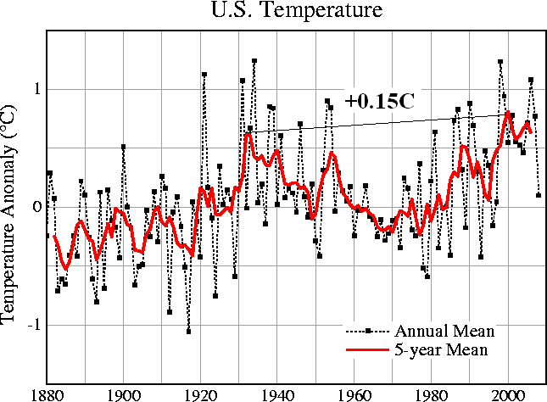

NASA’s Dr Edward Long looked at rural versus urban stations and found rural stations much more in line with the 1990s USHCN version

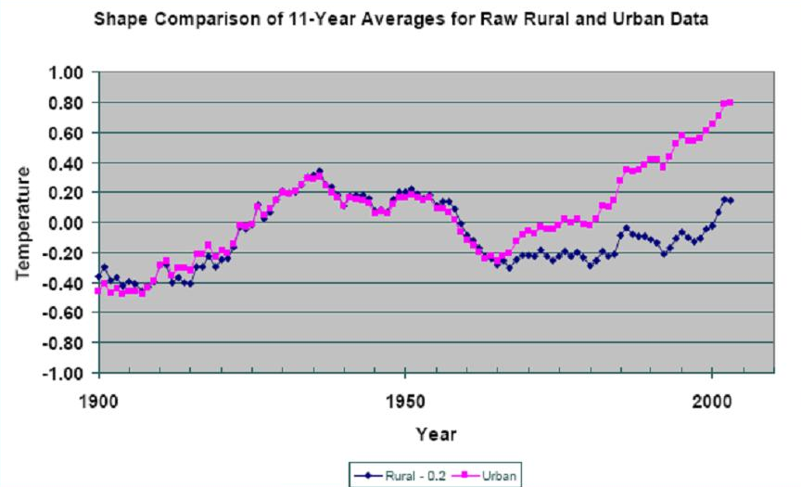

On a global scale, using the NASA version in 1980 version 2010, we see how efforts were made to not only show more warming in recent decades but suppress the warmth in the early to mid century.

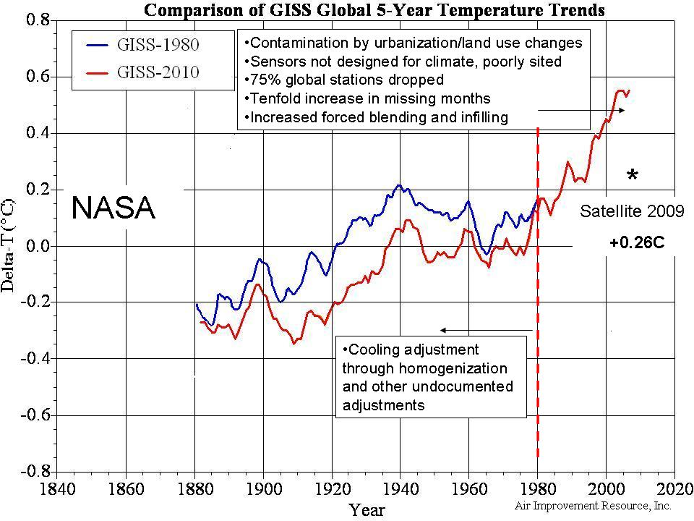

So when you hear it proclaimed it was the warmest month, season, year or decade, remember that is in the world of manipulated data. Yes this was a warm summer in many places (in San Diego it has been the coldest spring and summer on record to date - averaging 5F below normal). But last winter some parts of the US and Asia had the coldest winter ever and many locations since 1977/78, 1962/63 or 1971/72 even in the manipulated data. Then we were told that was weather not climate and to be expected with global warming and to ignore it. Do the same with the pockets of extreme warmth this summer.....and expect, like they are experiencing in the Southern Hemisphere another cold winter although with La Nina more like 2007/08 and 2008/09 than last winter and a resumption of the multidecadal cooling that began in 2002.

