To: New Hampshire Science, Technology and Energy Committee
From: Joseph D’Aleo, BS, MS, ABD Meteorology, CCM, AMS Fellow
Re: HB 519
Date February 10, 2011

Thank you for this opportunity to address you about this important bill and the science that supports it passage.

In my short time, I would like to address three points:
- CO2 is not a pollutant but a beneficial gas. Forced reduction of CO2 emissions which will increase energy bills and costs of goods and services will have no measurable impact on climate

- New Hampshire temperatures have shown no significant trends over the last century

- Claims of significant increases of average temperatures are false. Man’s influence is mainly through land use changes (urbanization). Observed cyclical changes are explained entirely by natural factors

- CO2 has been increasing but it is not a pollutant but a beneficial gas

- The average human emits 2.3 lbs of CO2 per day through respiration. Animal life likewise contributes.

- In this hearing room and most classrooms, auditoriums and gathering places, CO2 concentrations are two to three times higher than the ambient (free air) levels of around 388 ppm

- In submarines, the level may reach 20 to 40 times the ambient levels with no ill effects

- The globe has benefited in recent decades from minor cyclical warming and increases in CO2. NASA estimated an increase of yields by 30% over 50 years with 10% more arable land due to increased CO2 and slight cyclical warming

- CO2 enriched plants are more vigorous and drought resistant and have lower water irrigation needs. CO2 benefits crops under moisture stress most!

- Nurseries pump CO2 into greenhouses to 1000 ppm to enhance plant growth

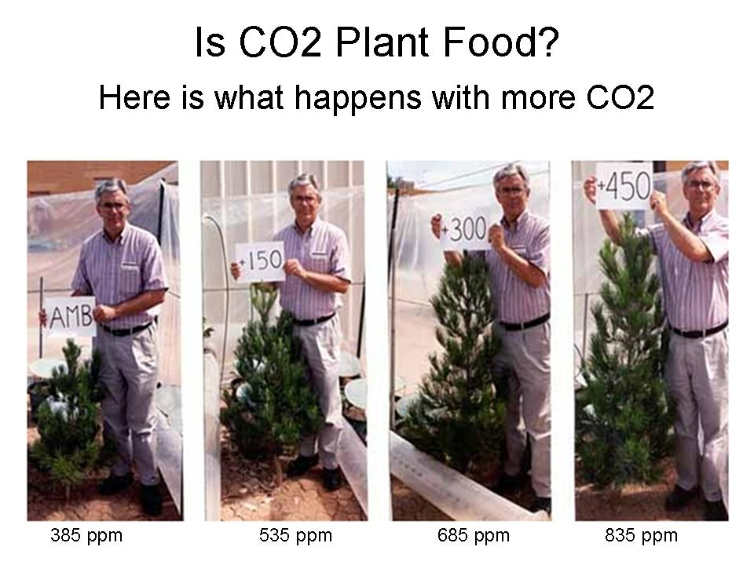

- Yale professor Robert Mendehlson testified to congress in 2000, climate change as projected then by IPCC would result in benefits of up to $23B/year to agriculture and forestry

- An extensively referenced 360-page book “The Many Benefits of Atmospheric CO2” by the Idso’s lists fifty-five benefits of atmospheric CO2 enrichment

But even if CO2 did cause warming, RGGI’s forced reduction would be futile while harming the state’s economy and increasing costs for our citizens.

- Under RGGI, the direct impacts from New Hampshire’s CO2 emissions would result in a global temperature “savings” of 0.00002°C (two one-hundred thousandths of a degree). These numbers are scientifically insignificant, inconsequential, and undetectable (from Knappenberger using Wigley 1998 model).

- At the current rate of emissions growth, the emissions reductions in New Hampshire as proposed by RGGI in the year 2018 will be completely replaced by foreign emissions growth in just 8 hours - literally overnight

- RGGI represents the epitome of an all pain and no gain scenario.

- Temperatures in New Hampshire and in the United States and in non urban contaminated rural areas globally exhibit a multidecadal cyclical behavior with no statistically significant long term trends (Source NOAA NCDC).

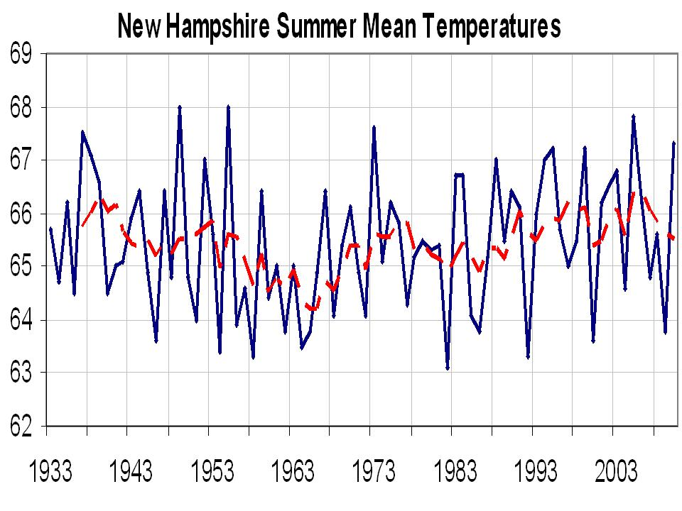
Slight annual warming is due to urbanization.

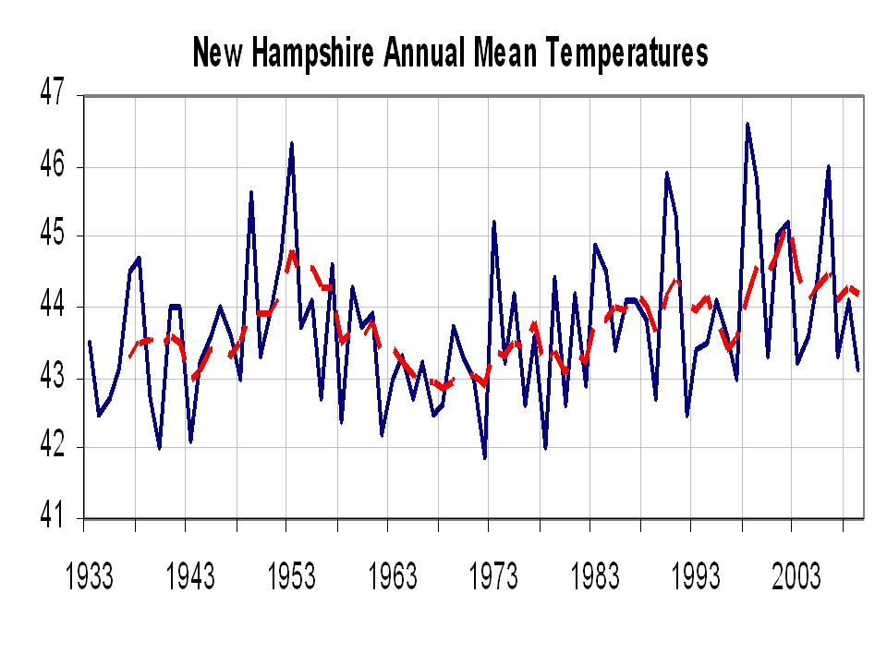
3. Claims of a significant warming trend in the United States are false.
The original US climate data set (USHCN v1) was considered the best in the world. It had an adjustment to account for warming from rapidly growing urban centers.
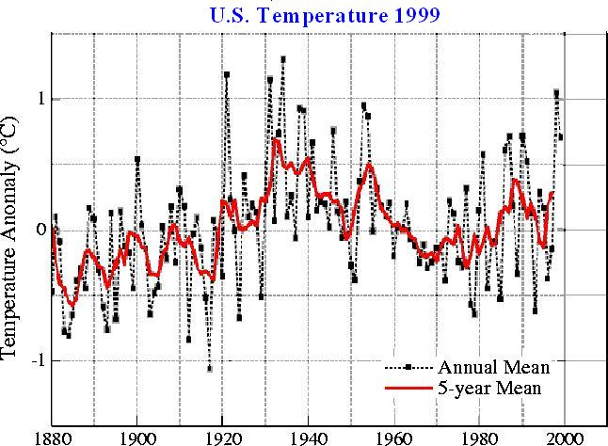

“The U.S. has warmed during the past century, but the warming hardly exceeds year-to-year variability. Indeed, in the U.S. the warmest decade was the 1930s and the warmest year was 1934.” James Hansen 1999

NOAA removed the urban adjustment in 2007. This cooled the 1940 peak and warmed up recent decades. The change is shown for the US below.
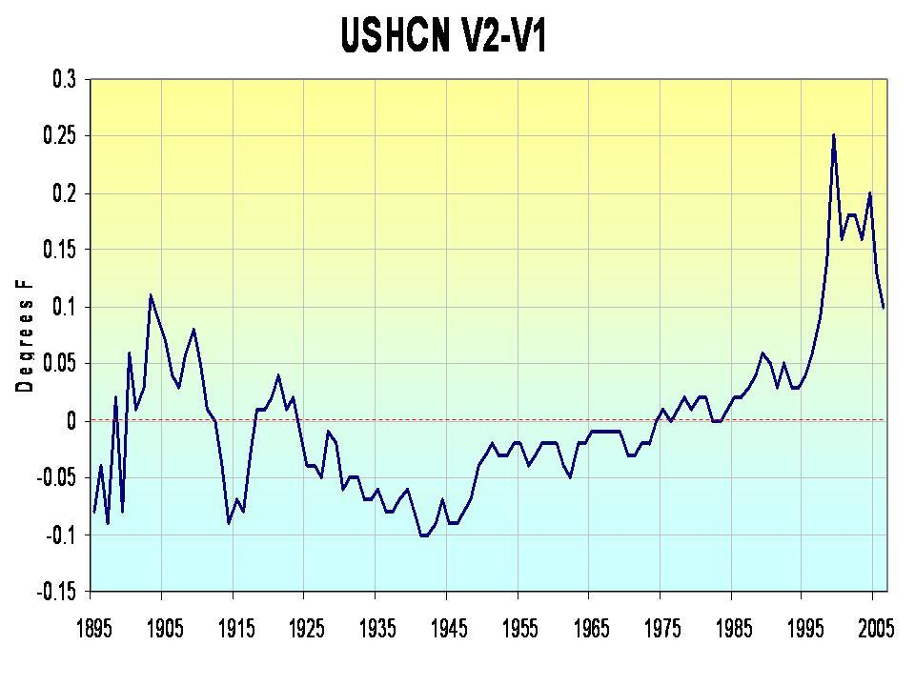
It still showed a cyclical pattern with a NEGATIVE correlation of CO2 and temperatures over half the time showing CO2 not the primary climate driver.
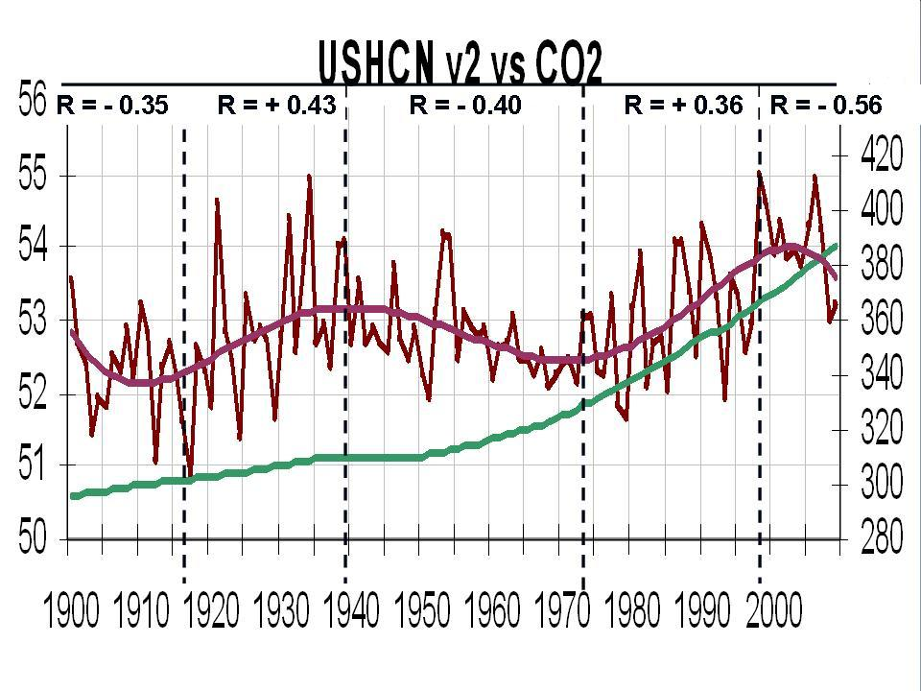
Numerous peer-reviewed papers have estimated local issues like urbanization may account for 30%, 50% or more of the warming.

Multidecadal cycles in the ocean and sun correlate far better (always positive) with temperatures than CO2.

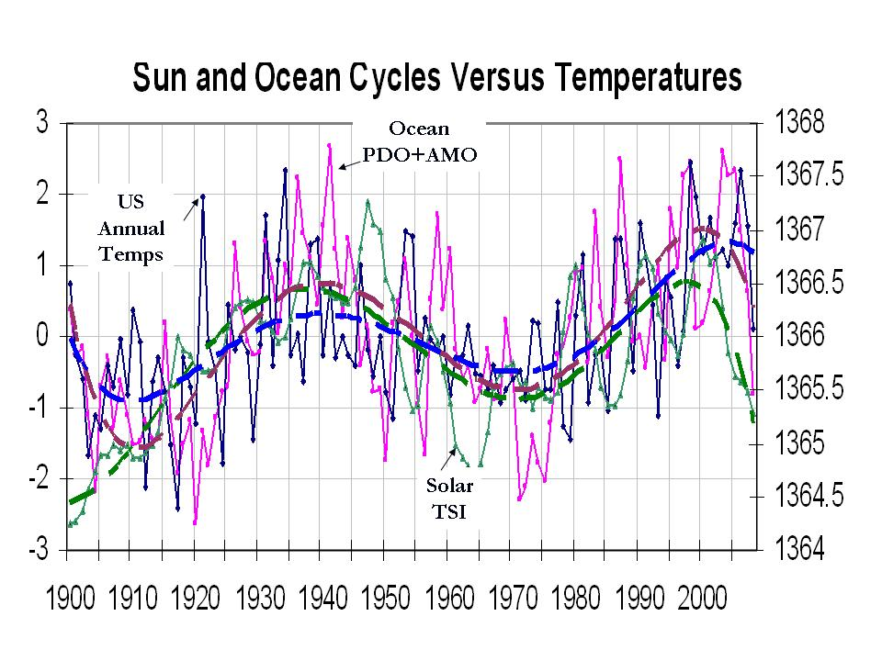
SUMMARY
CO2 is not a pollutant but a beneficial gas. Global climate change is primarily natural. Man’s role is primarily through urbanization and land use changes. Attempts to control climate through CO2 controls is therefore unnecessary and futile and would result in pain (negative economic impact) with absolutely no gain.

Joseph S. D’Aleo

BS, MS Meteorology University of Wisconsin
ABD New York University – Air Resources Meteorology
CCM, AMS Fellow, Chair AMS Committee on Weather Analysis and Forecasting
Professor and chairman Meteorology/Climatology Dept. Lyndon State College, VT
Weather Producer CBS Weather Center NYC, ABC Good Morning America
Co-Founder and first Director of Meteorology, The Weather Channel
Chief Meteorologist WSI Corporation and Intellicast.com
Partner Hudson Seven LLC hedge fund – ag and energy commodities
Senior Ag forecaster WSI
Executive Director, ICECAP http://icecap.us
Meteorology advisor, SPPI
Senior weather analyst WeatherBell Analytics

