URBAN HEAT ISLAND
We are all familiar with the fact that cities are generally warmer than the surrounding, more rural areas. We see it referenced most nights in our television weather reports. It is especially significant on nights with clear skies and light winds which favor radiational cooling. This is most significant in the rural areas but in the city, the excess heat absorbed during the day and the local heat sources maintain higher nighttime readings. During the days or nights with strong winds and clouds the differences are minimized due to mixing and the advective cooling of the city by the winds.
Because of this relative warmth, a city may be referred to as an urban heat island.
The reason the city is warmer than the country comes down to a difference between the energy gains and losses of each region. There are a number of factors that contribute to the relative warmth of cities according to Ackerman:
- During the day in rural areas, the solar energy absorbed near the ground evaporates water from the vegetation and soil. Thus, while there is a net solar energy gain, this is compensated to some degree by evaporative cooling. In cities, where there is less vegetation, the buildings, streets and sidewalks absorb the majority of solar energy input.
- Because the city has less water, runoff is greater in the cities because the pavements are largely nonporous (except by the pot holes). Thus, evaporative cooling is less which contributes to the higher air temperatures.
- Waste heat from city buildings, cars and trains is another factor contributing to the warm cities. Heat generated by these objects eventually makes its way into the atmosphere. This heat contribution can be as much as one-third of that received from solar energy.
- The thermal properties of buildings add heat to the air by conduction. Tar, asphalt, brick and concrete are better conductors of heat than the vegetation of the rural area.
- The canyon structure that tall buildings create enhances the warming. During the day, solar energy is trapped by multiple reflections off the buildings while the infrared heat losses are reduced by absorption.
- The urban heat island effects can also be reduced by weather phenomona. The temperature difference between the city and surrounding areas is also a function of winds. Strong winds reduce the temperature contrast by mixing together the city and rural air.
- The urban heat island may also increase cloudiness and precipitation in the city, as a thermal circulation sets up between the city and surrounding region.
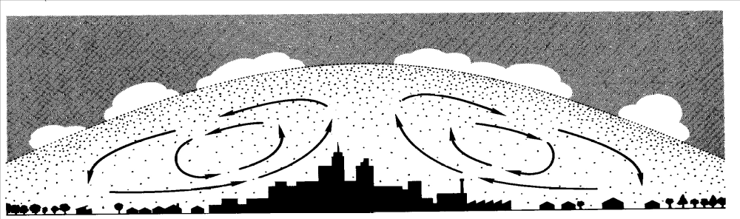
The urban heat island is clearly evident in numerous statistical studies of surface air temperatures over the years including Woolum, 1964 and in the depictions below from Critchfield 1983).
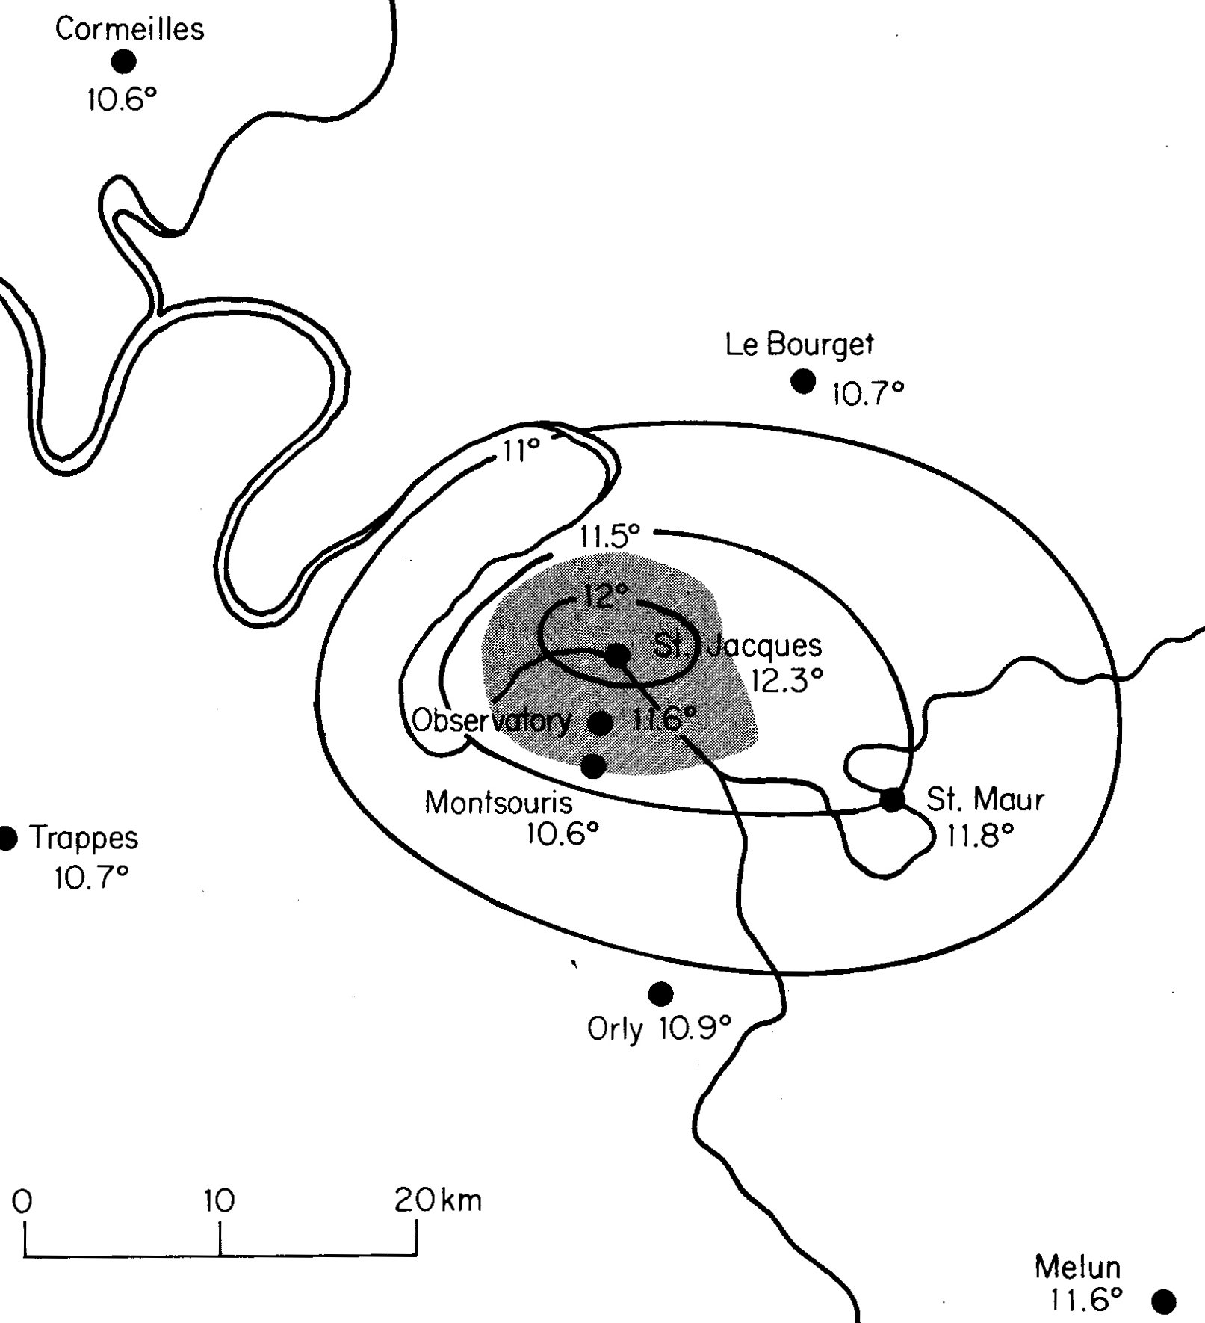
Mean annual surface temperatures for Paris and Surroundings (Crtitchfield 1983)
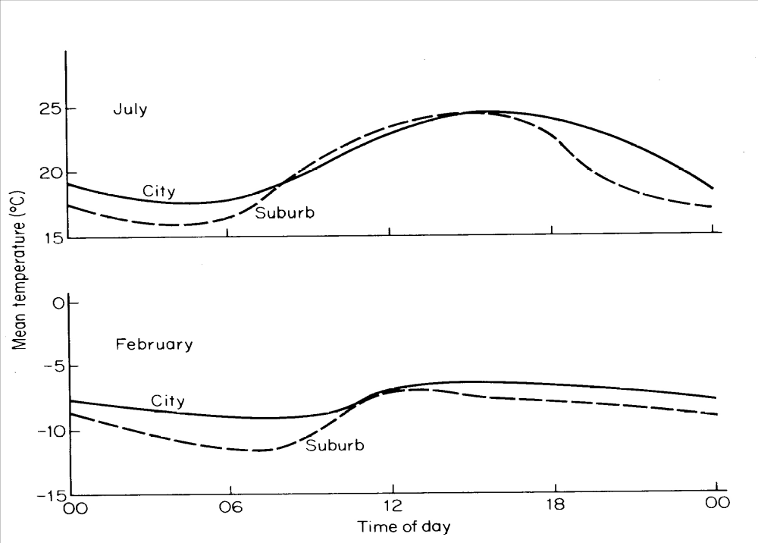

Diurnal temperature variations for Urban Vienna and suburban Hohe Warte for July and February (Critchfield 1983)

The variance across a city and surroundings is shown in the following courtesy of the EPA.

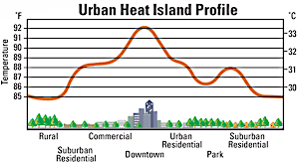
Remote sensing from satellite radiometers show this urban warming effect. The satellite image of Atlanta, GA is an example of a surface-based measurement, which records radiant emissions, or energy reflected and emitted from the land, including roofs, pavements, vegetation, bare ground, and water. ‘’
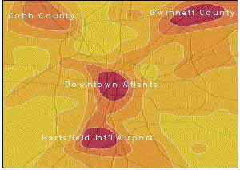
Satellite (Lands at TM) image of multi-nodal heat island in Atlanta, GA. Darker
It is also apparent on cloud-free satellite images, as the 11 micron image below produced with the Advanced Very High Resolution Radiometer (AVHRR) shows.
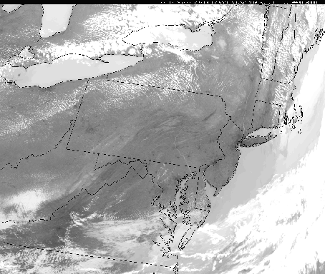
The image has a spatial resolution of approximately 1 km. At this wavelength, the AVHRR measures the amount of radiant energy emitted by the surface and the tops of clouds, which is proportional to the temperature of the emitting body. The warmer the body, the greater the amount of radiant energy it emits. White portions of the image represent cold objects (e.g., cloud tops) and dark regions are warm areas.
A close up with warmer temperatures shown in red is below
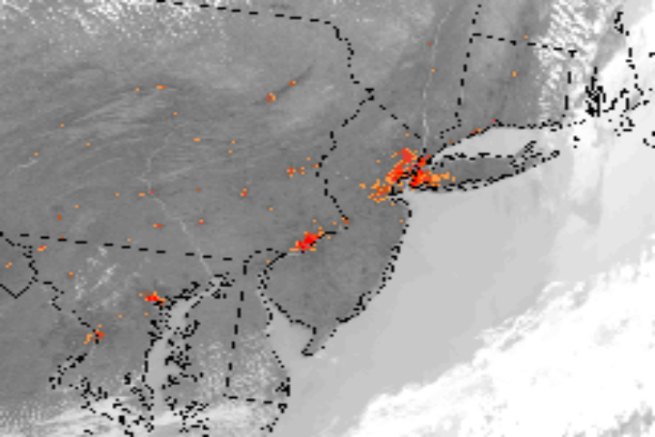
IPCC AND NCDC VIEW OF URBANIZATION

Peterson and others support the IPCC viewpoint at towns with less than 10,000 populations are towns without the need for adjustment for urbanization. Oke (1973 and
Torok et al (2001) show that even towns with populations of 1000 people have urban heating of about 2.2 C compared to the nearby rural countryside. Since the UHI increases as the logarithm of the population or as about 0.73 log (pop), a village with a population of 10 has an urban warming of 0.73 C, a village with 100 has a warming of 1.46 C, a town with a population of 1000 people already has an urban warming of 2.2 C, and a large city with a million people has a warming of 4.4 C (Oke, 1973).

As Doug Hoyt has noted, in 1900, world population is 1 billion and in 2000, it is 6 billion for an increase of a factor of six. If the surface measuring stations are randomly distributed and respond to this population increase, it would equal 2.2 log (6) or 1.7 C, a number already greater than the observed warming of 0.6 C. If however we note that UHIs occur only on land or 29% of the Earth’s surface, than the net global warming would be 0.29*1.7 or 0.49 C which is close the observed warming. It is not out of the realm of possibility that most of the twentieth century warming was urban heat islands.

References:

Ackerman, S., UW SSEC Urban Heat Islands

Christy, J. R. And R. W. Spencer, 2004. 25 years of satellite data show Â&euro;̃global warming' of only 0.34 . Press release, University of Alabama, Huntsville, AL (http://uahnews.uah.edu/scienceread.asp?newsID=196).

Christy, J. R., R. W. Spencer, W. B. Norris, W. D. Braswell and D. E. Parker, 2003. Error estimates of Version 5.0 of MSU/AMSU bulk atmospheric temperatures. Journal of Atmospheric and Oceanic Technology, 20, 613-629.

Davey, C. A. and R. A. Pielke Sr., 2004: Microclimate exposures of surface-based weather stations - implications for the assessment of long-term temperature trends. Bull. Amer. Meteor. Soc., submitted.

Hansen, J., Sato, M. and Ruedy, R. 1995. Long-term changes of the diurnal temperature cycle: Implications about mechanisms of global climate change. Atmospheric Research, 37, 175-209.

Hansen, J., and L. Nazarenko 2003. Soot climate forcing via snow and ice albedos. Proc. Natl. Acad. Sci., 101, 423-428.

Hoyt, Doug Urban Heat Islands and Land Use Changes

D. and A. Moberg, 2003. Hemispheric and Large-Scale Air Temperature Variations: An Extensive Revision and Update to 2001. Journal of Climate, 16, 206-223.

Kalnay, E. and M. Cai, 2003. Impact of urbanization and land-use change on climate. Nature 423, 528 - 531

Mann, M. E., Bradley, R. S. and Hughes, M. K. 1998. Global-scale temperature patterns and climate forcing over the past six centuries. Nature, 392, 779-787.

Marland, G., R. A. Pielke, Sr., M. Apps, R. Avissar, R.A. Betts, K.J. Davis, P.C. Frumhoff, S.T. Jackson, L. Joyce, P. Kauppi, J. Katzenberger, K.G. MacDicken, R. Neilson, J.O. Niles, D. dutta S. Niyogi, R.J. Norby, N. Pena, N. Sampson, and Y. Xue, 2003. The climatic impacts of land surface change and carbon management, and the implications for climate-change mitigation policy. Climate Policy, accepted.

McIntyre, S. and McKitrick, R. 2003. Corrections to the Mann et al. (1998) proxy data base and Northern Hemispheric average temperature series. Energy and Environment,14, 751-771.

Molg, T., D. R. Hardy, and G. Kaser, 2003. Solar-radiation-maintained glacier recession on Kilimanjaro drawn from combined ice-radiation geometry modeling, J. Geophys. Res., 108, 4731.
Myer, W. B., 1991: Urban heat island and urban health: Early American perspective, Professional Geographer, 43 No. 1, 38-48.
Oke, T.R. 1973. City size and the urban heat island. Atmospheric Environment, 7 769-779.

Pielke, R. A., Sr., J. Eastman, T. N. Chase, J. Knaff, and T. G. F. Kittel, 1998. The 1973-1996 trends in depth-averaged tropospheric temperature, J. Geophys. Res., 103, 16,927-16,933.

Pielke, R. A., Sr., J. Eastman, T. N. Chase, J. Knaff, and T. G. F. Kittel, 1998. Correction to "The 1973-1996 trends in depth-averaged tropo-spheric temperature," J. Geophys. Res., 103, 28, 909-911.

Santer, B. D., et al., 2000. Interpreting differential temperature trends at the surface and in the lower troposphere. Science, 287, 1227-1232.

Torok, S. J., Morris, C. J. G., Skinner, C. and Plummer, N. 2001. Urban heat island features of southeast Australian towns. Australian Meteorological Magazine, 50, 1-13.
Woolum, C. A., 1964: Notes from a study of the microclimatology of the Washington, DC area for the winter and spring seasons. Weatherwise, 17, No. 6)
EXPERTS/LINKS:
Roger Pielke Sr’;s Climate Science web log http://climatesci.atmos.colostate.edu/category/climate-change-forcings-and-feedbacks/
Roger A. Pielke Sr.
Senior Research Scientist
Email: pielkesr@cires.colorado.edu
970-491-8293 (phone)
970-491-3314 (fax)

Hoyt, Doug, Urban heat Islands and Land Use Changes http://www.warwickhughes.com/hopyt/uhi.htm

Dr. Steve Ackerman/, University of Wisconsin Urban Heat Islands

