UNITED STATES AND GLOBAL DATA INTEGRITY ISSUES

By Joseph D’Aleo
Update October 8, 2009

ABSTRACT

Issues with the United States and especially the global data bases make them inadequate to use for trend analysis and thus any important policy decisions based on climate change. These issues include inadequate adjustments for urban data, bad instrument siting, use of instruments with proven biases that are not adjusted for, major global station dropout, an increase in missing monthly data and questionable adjustment practices.

We hear official press releases announcing 2008 was the 8th, 9th or tenth warmest in 127 to 147 years in the various global data bases. Yet the NASA satellite record shows the year for the globe was the coldest this decade and 14th coldest in the 30 years of satellite monitoring. Here we will show how these global estimates are contaminated and can’t be trusted and certainly should not be used for important policy decisions.
US CLIMATE DATA

NOAA NCDC USHCN
When first implemented in 1990 as USHCN version1, it employed 1221 stations across the United States. In 1999, NASA’s James Hansen published this graph of USHCN version 1 annual mean temperatures:

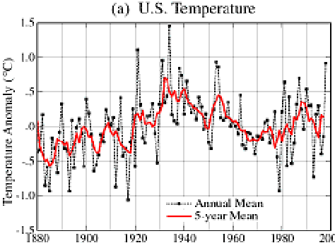

About which Hansen correctly noted: “The U.S. has warmed during the past century, but the warming hardly exceeds year-to-year variability. Indeed, in the U.S. the warmest decade was the 1930s and the warmest year was 1934.”

USHCN was generally accepted as the world’s best data base of temperatures with the stations most continuous and stable, and adjustments made for time of observation, urbanization, known land use changes around sites, and instrumentation changes, each of which can produce major contamination issues for temperature data.

URBAN HEAT ISLAND

There is no real dispute that weather data from cities, as collected by meteorological stations, is contaminated by urban heat island (UHI) bias, and that this has to be removed to identify climatic changes or trends. In cities, vertical walls, steel and concrete absorb the sun’s heat and are slow to cool at night. More and more of the world is urbanized (population increased from 1.5 B to 6 B in 1900s).

The UHI effect occurs not only for big cities but also for towns. Oke (who won the 2008 American Meteorological Society’s Helmut Landsberg award for his pioneer work on urbanization) had a formula for the warming that is tied to population. Oke (1973) found that the UHI (in °C) increases according to the formula

UHI= 0.73 log₁₀ POP

where pop denotes population. This means that a village with a population of 10 has a warm bias of 0.73°C, a village with 100 has a warm bias of 1.46°C, a town with a population of 1000 people has a warm bias of 2.2C°, and a large city with a million people has a warm bias of 4.4°C.

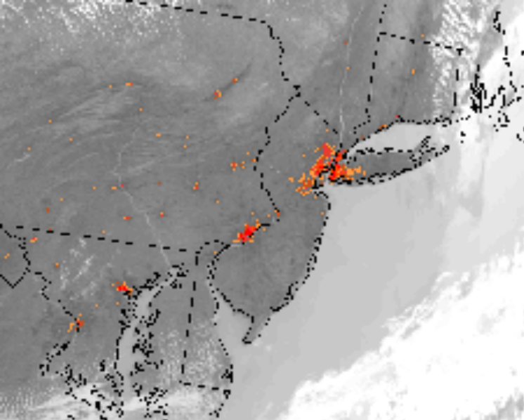
Urban heat islands as seen from infrared sensors onboard satellites.

Goodrich (1996) showed the importance of urbanization to temperatures in his study of California counties in 1996. He found for countires with a million or more population the warming from 1910 to 1995 was 4F, for counties with 100,000 to 1 million, 1F and for counties with less than 100,000, no change (0.1F).

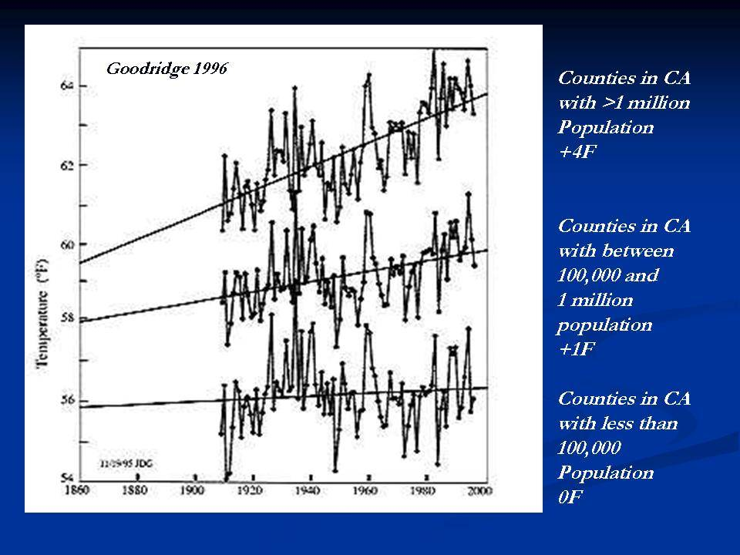

NCDC’s Tom Karl (1988) employed a similar scheme for the first USHCN data base (released in 1990) that was the best data set available at that time. He noted that the national climate network formerly consisted of predominantly rural or small towns with populations below 25,000 (as of 1980 census) and yet that a UHI effect was clearly evident.

Tom Karl et al’s adjustments were smaller than Oke had found (0.22°C annually on a town of 10,000 and 1.81°C on a city of 1 million and 3.73°C for a city of 5 million).

Karl observed that in smaller towns and rural areas the net UHI contamination was relatively small but that significant anomalies showed up in rapidly growing population centers.

USHCN also maintained a METADATA base (not perfect) that identified changes in observing site locations and instrumentation and supposedly made adjustments accordingly, along with adjustment for change in the time of observation over the years.

NASA GISS US
GISS uses in the USA, southern Canada and northern Mexico an urbanization adjustment based on the amount of night time light measured by satellites from the station locations. Unlit stations are classified as rural stations. This does produce some adjustment and a reasonable plot of temperatures but as GISS notes, this is just less than 2% of the globe.”

The difference from their adjusted values and the NOAA no longer adjusted shows NOAA was misguided in their removal of the urban adjustment, with a net cooling of 0.2F in 1930s and warming of 0.4F near 2005. NOAA data adjusted to the GISS base period of 1951-1980.

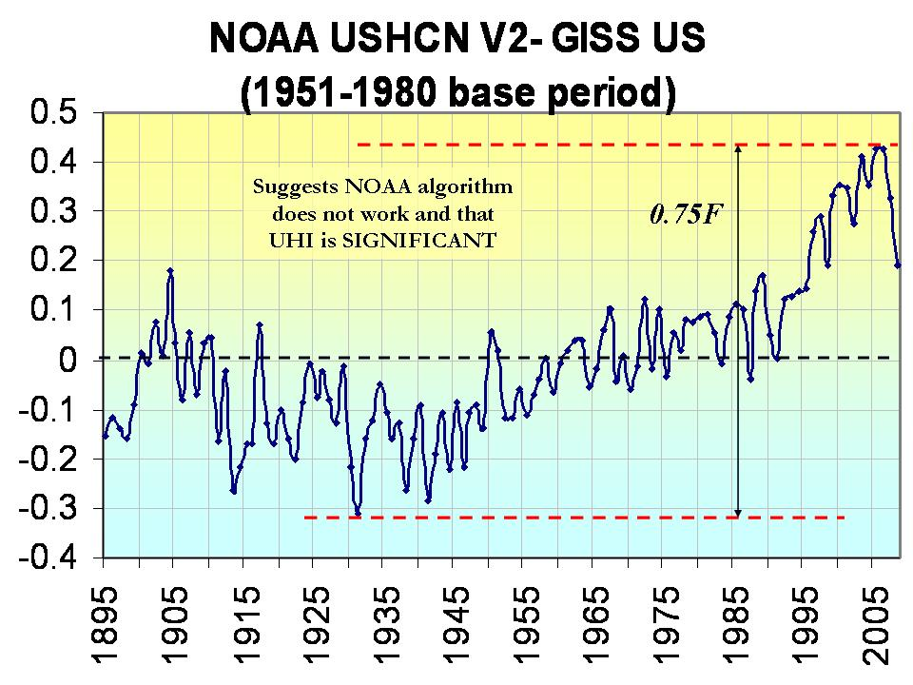

The net warming in the UHI adjusted GISS US data set from the peak around 1930 to the peak near 2000 was a meager 0.15C. It may be assumed the same would be true for the world if we could make a similar needed UHI adjustment.

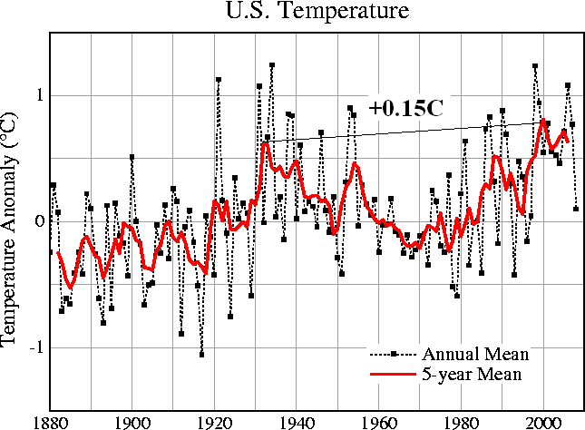

GISS Adjusted US Temperatures

INSTRUMENT CHANGES
Dr. Ben Herman at the University of Arizona confirmed in working with the climate station in Tucson, AZ that the new HO83 had a significant warm bias. This observation was based on the work by Gall et al. (1992) and Jones (1995). Stephen McIntyre has summarized in The HO-83 Hygro-thermometer (http://www.climateaudit.org/?p=1954) the findings by Tom Karl at al in 1995 of a discontinuity of about 0.5ºC before and after switchover. This change to the HO-83 seemingly went unadjusted for in the USHCN data base for the period from the 1980s to the late 1990s when the instruments were replaced.

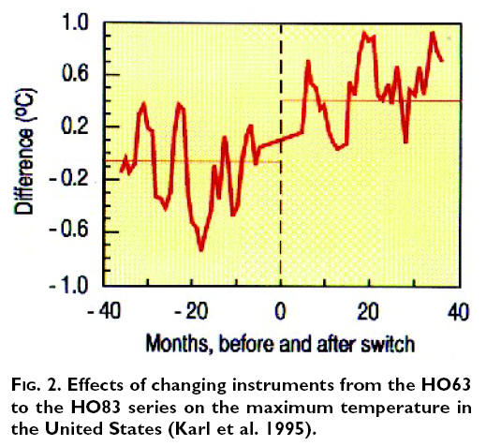

BAD SITING

Pielke and Davey (2005) found a majority of stations including climate stations in eastern Colorado did not meet WMO requirements for proper siting. He has extensively documented poor siting and land use change issues in numerous peer review papers, many summarized in the landmark paper Unresolved issues with the assessment of multi-decadal global land surface temperature trends (2007).

Anthony Watts started a volunteer effort to document siting issues with all 1221 stations in US. He and his team is now through over 919 stations. See the results on http://surfacestations.org and numerous examples highlighted on http://wattsupwiththat.wordpress.com. All of these siting issues identified introduce a warm bias.

Here are some examples:



USHCN Station Hopkinsville, KY (Pielke et al 2006)


Max/Min sensor near John Martin Reservoir, CO (Davey 2005)

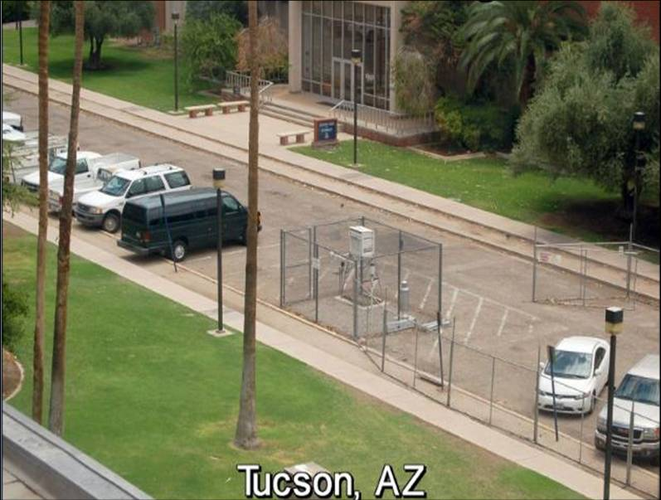
Tucson , Arizona in a parking lot on pavement.


Wickenburg, Arizona next to a building on a paved surface
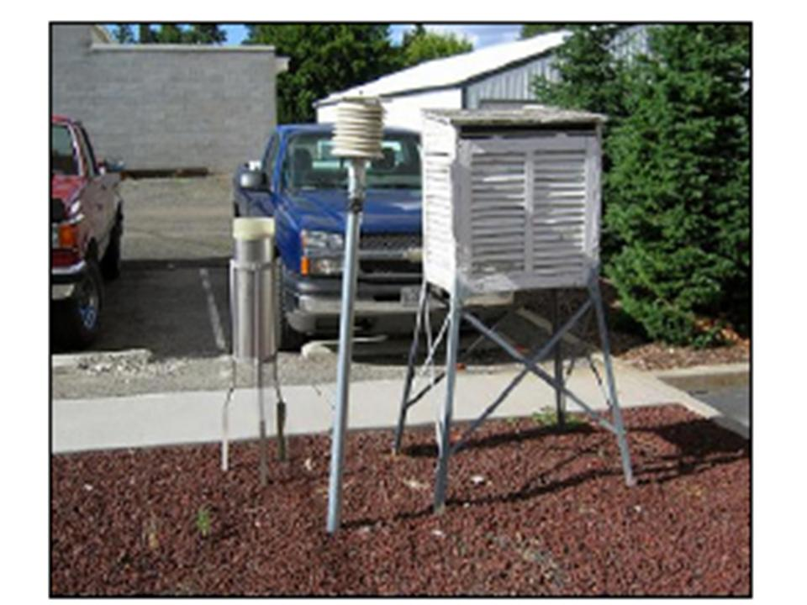
Waterville, WA over volcanic cinders

The vast majority of stations did not meet the governments own criteria for siting as established in the documentation for the Climate Reference Network.

Using the government’s own rating system, Anthony has shown a majority of the stations are inadequately sited (89% are CRN 3-5, 69% CRN 4-5 poor to very poor)

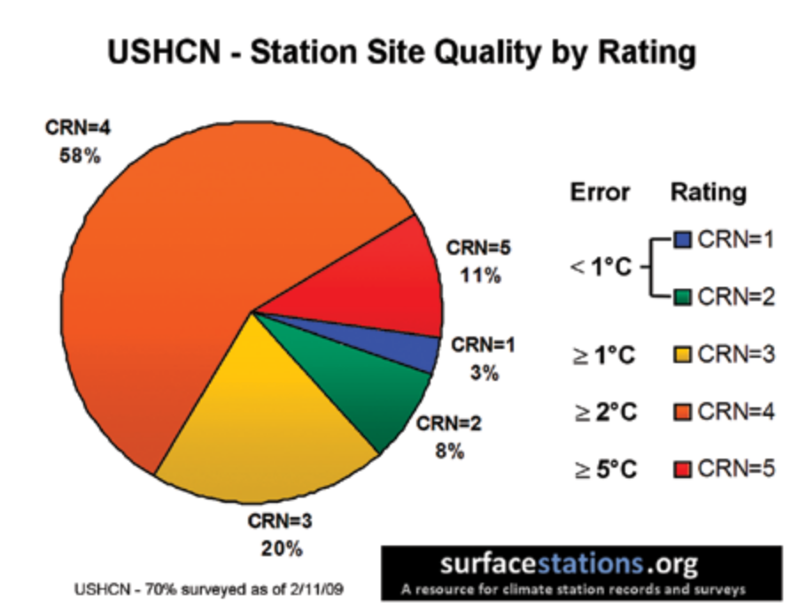
The distribution of poor and very poor (CRN 4, CRN 5) was widespread across all the states.

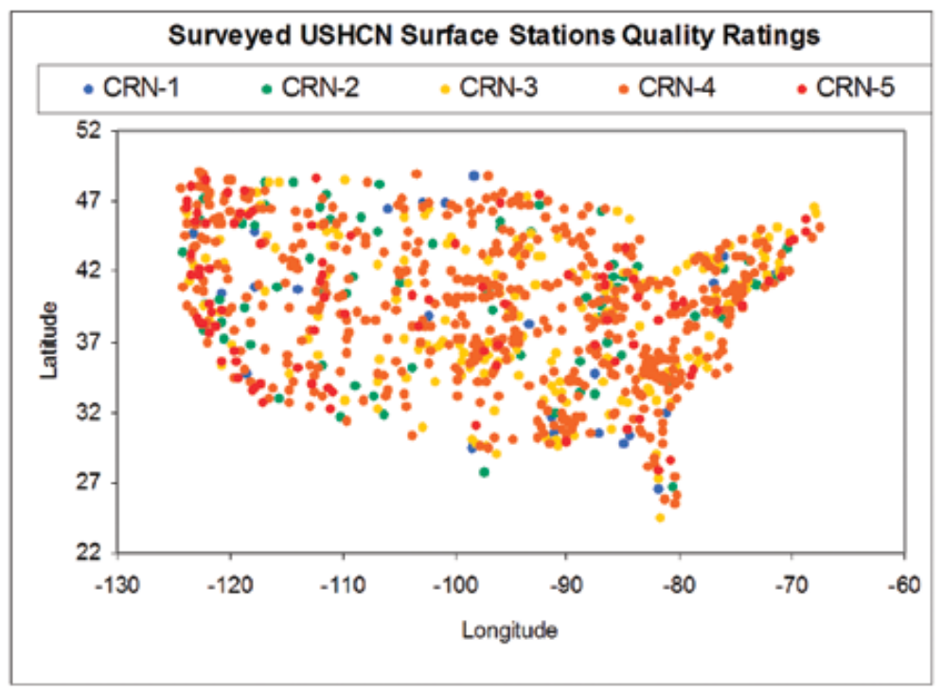

MAJOR CHANGES TO USHCN IN 2007
In 2007 the NCDC (the National Climatic Data Center), in its version 2 of USHCN, inexplicably removed the Karl UHI adjustment and substituted a CHANGE POINT ALGORITHM that looks for sudden shifts (discontinuities). This is best suited for finding site moves or local land use changes (like paving a road or building next to sensors or shelters) but not the slow ramp up characteristic of a growing town or city.
I had a conversation with NCDC’s Tom Karl two years ago when the USHCN version 2 was announced. I told Tom I had endorsed his 1988 Journal of Climate paper (Urbanization: Its Detection and Effect in the United States Climate Record) having been a fan of the work that Landsberg and Oke on whose work that paper depended on.
I asked him if USHCNv2 would no longer have an urbanization adjustment. After a few moments of silence, he told me he had asked those who had worked on version 2 that question and was reassured that the new algorithms would catch urban warming and other changes – including “previously undocumented inhomogeneities” (discontinuities that suggest some local site changes or moves that were never documented).
The difference between the old and new is shown here. Note the significant post 1995 warming and mid 20th century cooling due to deurbanization of the data base.

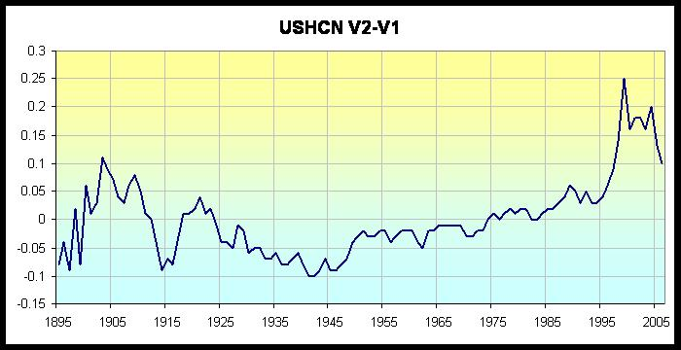

The change can be seen clearly in this animation.

The new algorithms are supposed to correct for urbanization, changes in siting and instrumentation by recognizing sudden shifts in the temperatures.

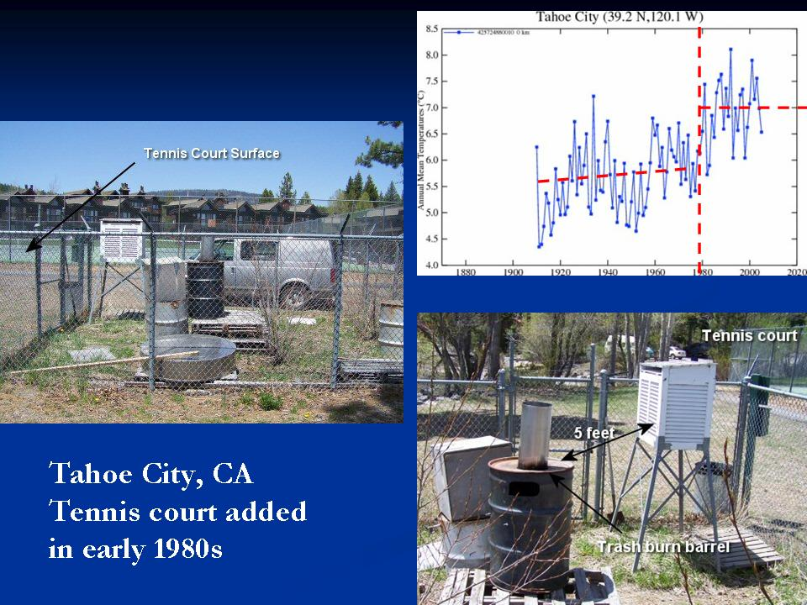

It should catch this kind of change above in Tahoe City, CA.

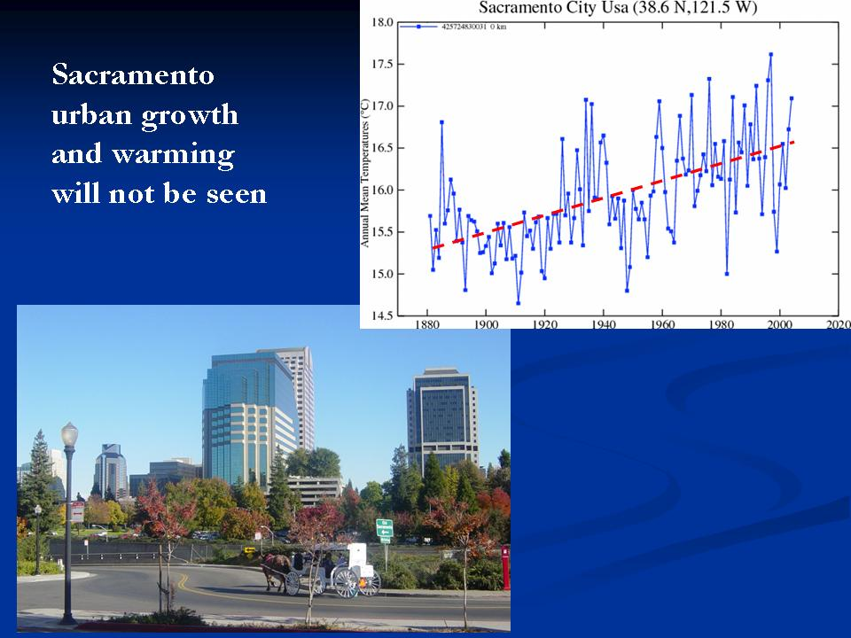

It is unlikely to catch the slow warming associated with the growth over many years of cities and towns as in Sacramento, CA above.
There is even some evidence that the algorithm does not catch some site changes it should catch. Take for example Lampasas, Texas as identified by Anthony Watts.



Lampasas, Texas site moved to near a building and street from a more appropriate grassy site after 2001. Note even with the new “homogeneity” adjustment (red) this artificial warming is left although the old data (blue) is cooled to accentuate warming even further.

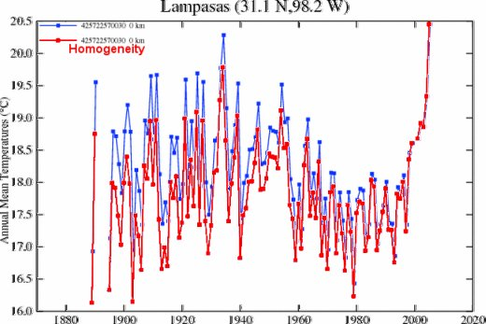

The net result is to make the recent warm cycle max more important relative to the early century max in the 1930s.

Comparison of the new USHCN to the GISS USHCN which does a UHI adjustment based on night lights shows the NOAA version has increased the warming relative to the GISS by 0.75F since3 1930.

I asked Tom Karl about the problems with siting and why they could not speed up the plans for a Climate Reference Network (at that time called NERON). He said he had presented a case for that to NOAA but had it turned down with the excuse from high levels at NOAA that the surface stations did not matter because we had satellite monitoring. The Climate reference network was capped at 114 stations but won’t provide meaningful trend assessment for about 10 years.
The NOAA attitude that the stations don’t matter is manifested in the disregard for the siting as Anthony Watts has now with 2/3rds of the network surveyed found only 12 % satisfactory (3% CRN#1 and 9% CRN#2) and with no attempts to resolve the issues Anthony has found and presented to the NCDC staff. The change of the algorithms which worked fine was either an attempt to find an easy way to detect previously unrecorded site changes or to make the USHCN show more recent warming to be more in line with the global data bases. In monthly press releases, no satellite measurements are ever mentioned although NOAA claimed that was the future of observations.

THE GLOBAL DATA BASES

NOAA gathers global station and ocean ship data and makes it available for the NCDC GHCN and NASA GISS analyses. NCDC and NASA perform adjustments on this data, slightly different but generally similar in magnitude. They are hampered by issues in the global network which are greater in number and magnitude than for the United States.
STATION DROPOUT AND OTHER INTEGRITY ISSUES

Globally a major issue is station dropout. Over 2/3rds of the world’s stations, many of them rural areas in the former Soviet Union, stopped reporting around 1990. Dr. Kenji Matsuura and Dr. Cort J. Willmott at the University of Delaware has prepared this animation. See the lights go out in 1990. The animation shows that Siberia suffered the biggest station falloff.

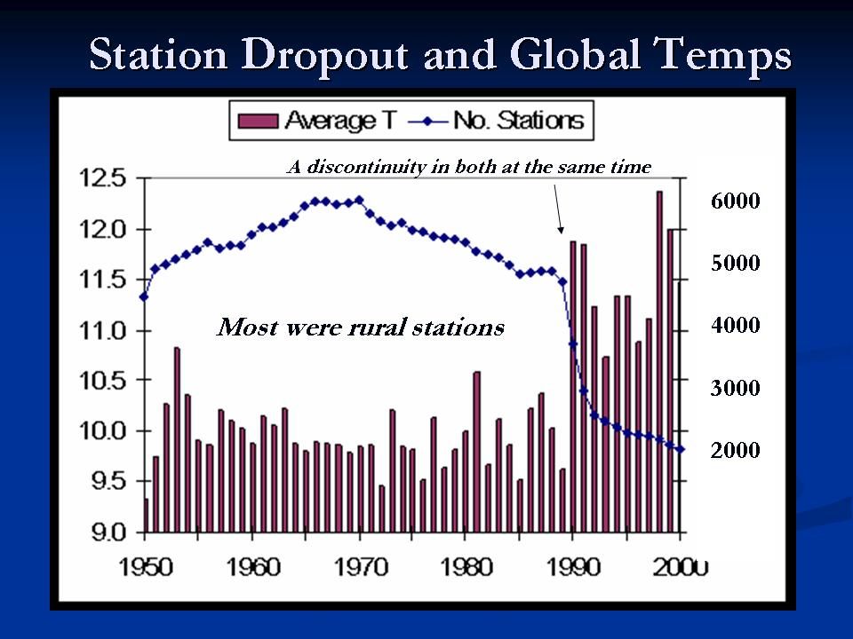
In the chart above you see how this drop off of global sites coincides with a sudden rise in mean of all remaining stations. The analysis below of station count is broken down by rural, suburban and urban categories. It clearly shows a substantial drop in the number of rural stations. The numbers of stations are higher because many stations are given new numbers for every documented move or change.

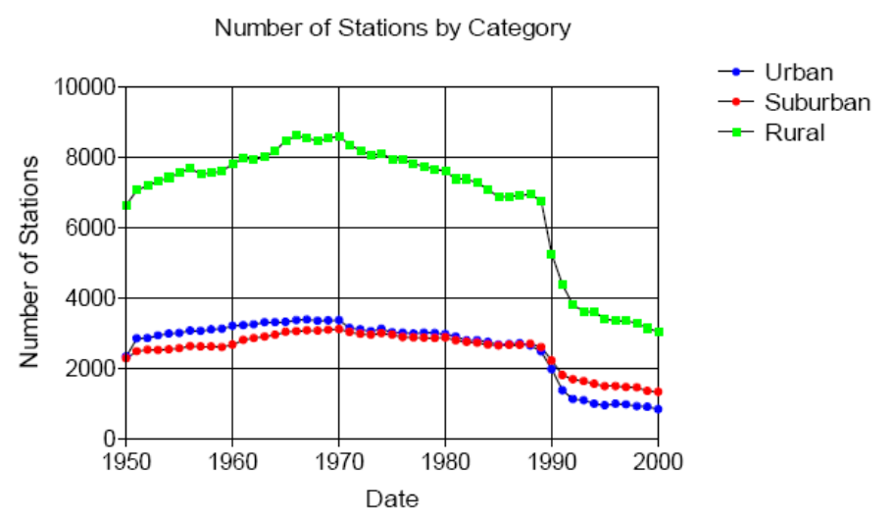

Average temperatures jumped when these other stations dropped out in all three categories but most notably in the rural data, suggesting that it was mainly colder, smaller, higher latitude stations that were no longer in the record (analyses above and below from Jonathan Drake)..
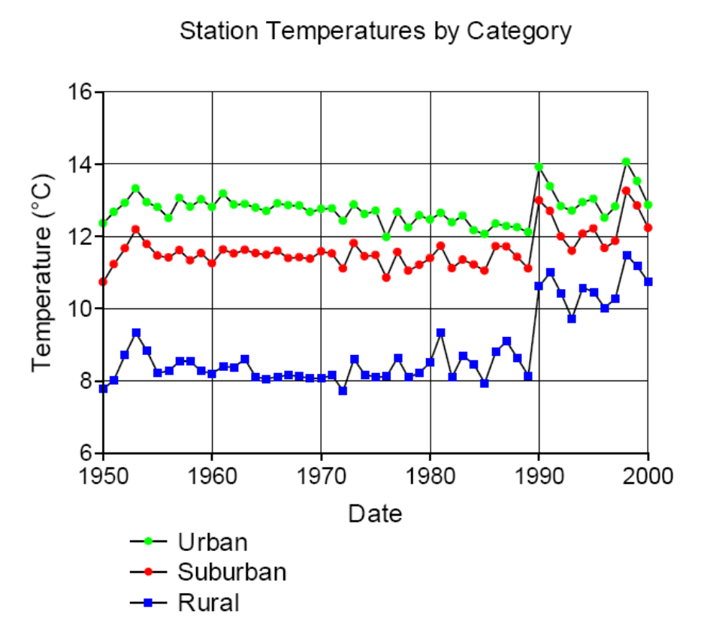
Global data bases all compile data into latitude/longitude based grid squares and calculate temperatures inside the square using data from the stations within it - or use the closest stations (weighted by distance) in nearby boxes. Thus a grid square, which at one time had rural stations, will find its mean temperature increasingly determined by the urban areas within that square or distant squares. This is why global data suggests that the greatest warming has occurred in Siberia, where the greatest dropout has occurred.
See the huge dropout of data in Africa, Canada and Siberia in the two maps from NASA GISS with 250 km smoothing from 1978 to 2008.

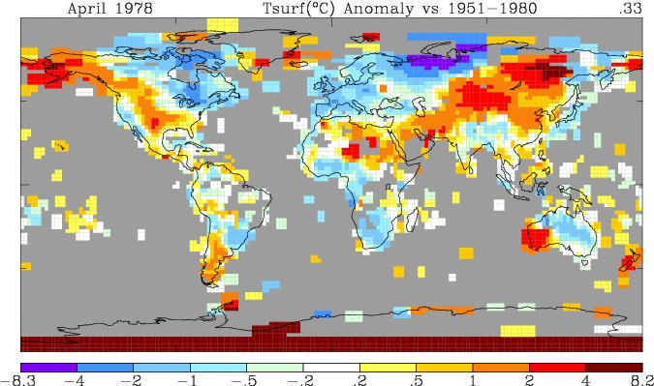

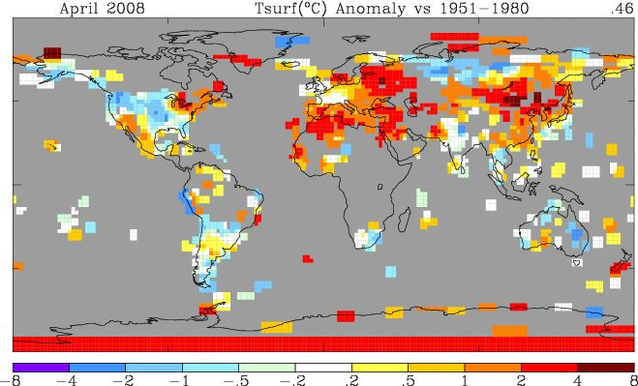

MISSING DATA INCREASES

In addition to station dropout, there has been a tenfold increase in missing months of data in places like the former Soviet Union.

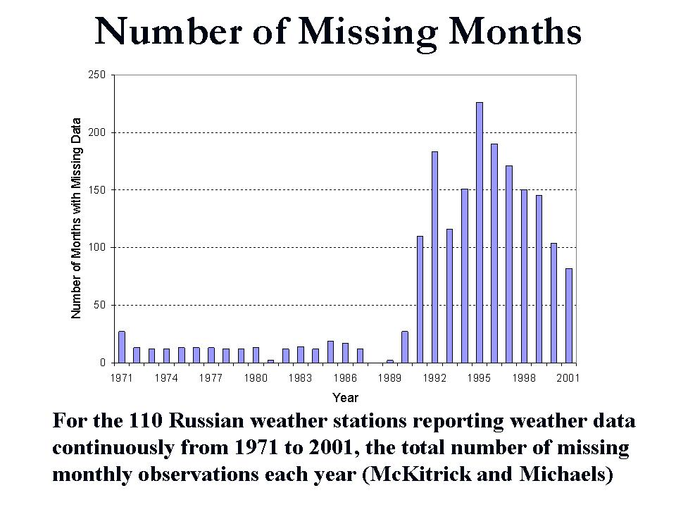
For these stations that are missing periods or some stations that are now closed, surrounding stations are used. One example is Ripogenus Dam in Maine.

Last summer, volunteers completed surveys of the United States Historic Climate Network (USHCN) temperature stations in Maine for Anthony Watts surface station evaluation project. The survey determined that every one of the stations in Maine was subject to microclimate or urbanization biases. One station especially surprised the surveyors, Ripogenus Dam, a station that was officially closed in 1995.

Despite being closed in 1995, USHCN data for this station is publicly available until 2006!
.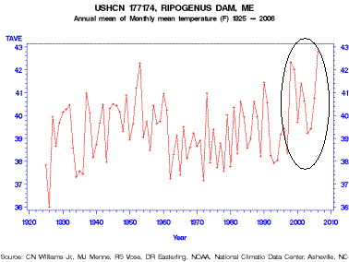

Part of the USHCN data is created by a computer program called “filnet” which estimates missing values. According to the NOAA, filnet works by using a weighted average of values from neighboring stations. In this example, data was created for a no longer existing station from surrounding stations, which in this case as we noted were all subject to microclimate and urban bias, no longer adjusted for. Note the rise in temperatures after this, perhaps before the best sited truly rural station in Maine was closed.

NO REAL URBAN ADJUSTMENT
HADLEY AND NOAA
Jones et al 1990 (Hadley CRU) concluded that UHI bias in gridded data could be capped at 0.05 deg C (not per decade, per century). Jones used data by Wang which Keenan has shown was fabricated. Peterson et al (1998) agreed with the conclusions of Jones and Easterling et al (1997) that urban effects on 20th century globally and hemispherically-averaged land air temperature time-series do not exceed about 0.05°C over the period 1900 to 1990. Peterson (2003) and Parker (2004) argue urban adjustment thus is not really necessary. Yet recall Oke showed a town of 1000 could produce a 2.2C (3.4F warming).
The most recent exposition of CRU methodology is Brohan et al 2006, which stated with respect to UHI that they included an allowance of 0.1 deg C/century in the uncertainty, but does not describe any "correction" to the reported average temperature. To make an urbanization assessment for all the stations used in the HadCRUT dataset would require suitable meta-data (population, siting, location, instrumentation, etc) for each station for the whole period since 1850. No such complete meta-data are available.
The homepage for the NOAA temperature index here cites Smith and Reynolds (2005) as authority. Smith and Reynolds, in turn, state that they use the identical procedure as CRU, i.e. they make an allowance in uncertainty, but do not correct the temperature index itself. The population of the world went from 1.5 to 6.5 billion from 1900 to 2000, yet NOAA and CRU ignore population growth in the data base with only a 0.1C uncertainty adjustment.
Runnalls and Oke (2006) concluded that “Gradual changes in the immediate environment over time, such as vegetation growth, or encroachment by built features such as paths, roads, runways, fences, parking lots, and buildings into the vicinity of the instrument site typically lead to trends in the series.

Distinct régime transitions can be caused by seemingly minor instrument relocations (such as from one side of the airport to another, or even within the same instrument enclosure) or due to vegetation clearance.
This contradicts the view that only substantial station moves, involving significant changes in elevation and/or exposure are detectable in temperature data.”
More than half dozen peer reviewed papers found that the lack of adequate UHI and local land use change adjustments could account for up to 50% of the warming since 1900.
In the areas of greatest warming, Siberia, besides dropout and a tenfold increase in missing monthly data, there were numerous issues related to prior temperatures In the Soviet era. city and town temperatures determined allocations for funds and fuel, so it is believed that cold temperatures were exaggerated in the past, which introduced an apparent warming when more honest measurements began to be made. Also Anthony Watts has found that in many Russian towns and cities, heating pipes are in the open. Any sensors near these pipes would be affected.

GISS GLOBAL

Is NASA better? Steve McIntyre has taken an in-depth look at the data adjustments made to NASA's GISS data set. The findings are summarized very well in Ken Gregory of Friends of Science’s “Correct the Correction”.

“NASA’s Goddard Institute of Space Studies (GISS) publishes a global temperature index. The temperature record is contaminated by the effects of urban development and land use changes. NASA applies an “urbanization adjustment” to adjust the temperature histories to eliminate these effects. The resulting GISS temperature index is supposed to represent what the temperatures would have been in the absence of urbanization and land use changes. Most scientists assume that these adjustments are done correctly.

An audit by researcher Steve McIntyre reveals that NASA has made urban adjustments of temperature data in its GISS temperature record in the wrong direction. The urban adjustment is supposed to remove the effects of urbanization, but the NASA negative adjustments increases the urbanization effects. The result is that the surface temperature trend utilized by the International Panel on Climate Change (IPCC) is exaggerated.

“Outside of the USA, southern Canada and northern Mexico, GISS uses population data to define rural stations. “We use the definition of Peterson et al 1997 for these categories: that is, rural areas have a recent population of less than 10,000, small towns between 10,000 and 50,000 and urban areas more than 50,000. These populations refer to approximately 1980.”

The GISS sites are defined to be “rural” if the town has a population of under 10,000. Unfortunately, the population data utilized by GISS to classify the stations is out of date. Stations at cities with populations greatly exceeding 10,000 are incorrectly classified as rural. For example, in Peru, there are 13 stations classified as rural. Of these, one station is located at a city with a population of 400,000. Five stations are at cities with populations between 50,000 and 135,000.

Steve McIntyre says here, “If the supposedly “rural” comparanda are actually “urban” or “small towns” within the Hansen definitions, then the GISS “adjustment” ends up being an almost completely meaningless adjustment of one set of urban values by another set of urban values. No wonder these adjustments seem so random.”

A population increase of 500 in a town of 2000 people would have a much larger effect on temperature measurements than the same increase in a city of 500,000 people. A city with a growing population generally increases its area. A temperature station inside the city would be little affected by the expansion of the suburbs. However, a temperature station located just outside a city would be greatly affected by the city expanding around the station. This effect is shown in the following diagram.

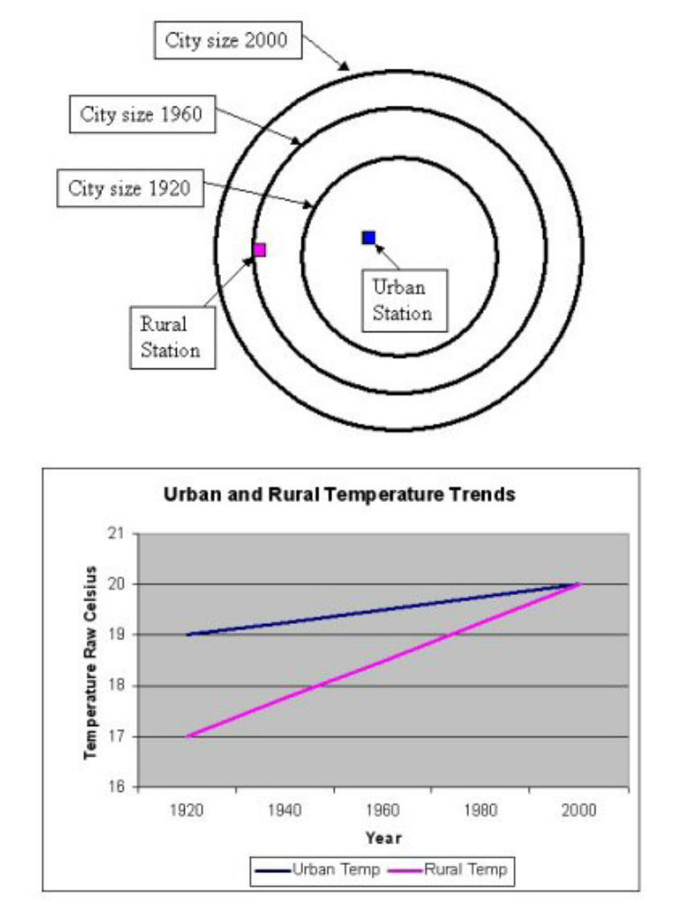

A hypothetical urban station is shown located in a city and a rural station is located outside the city in the year 1920. By 1960, the city has grown out to the rural station. The city growth has little effect on the urban station, but a much larger affect on the rural station. By 2000, the rural station is completely surrounded by the city, so it has the same temperature as the urban station...

Now, as indicated in the graph, the unadjusted rural temperature trend is much greater than the urban station trend. According to the GISS urban adjustment procedure, the urban station trend is increased to match the rural station trend by reducing the past temperatures.

Here is an example of an urban negative adjustment from Peru:

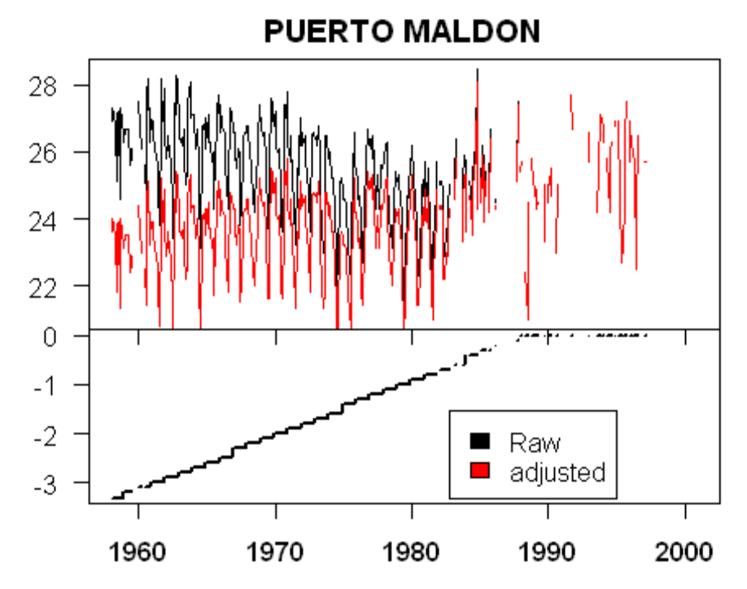
Note that the raw data shows no warming, but after applying the GISS urban adjustment, the adjusted data shows a significant warming trend. The adjustments are applied to reduce the past temperatures by up to 3 degrees Celsius. This is a very large adjustment when compared to the total warming of the twentieth century of 0.6 Celsius estimated by the IPCC.

A proper urban correction algorithm would reduce the warming trends of both stations to make an adjusted temperature record represent what would have happened if nobody lived near the stations.

Ross McKitrick and Patrick Michaels in December 2007 showed a strong correlation between urbanization indicators and the “urban adjusted” temperatures, indicating that the adjustments are inadequate. Their conclusion is: "Fully correcting the surface temperature data for 'non-climatic effects reduce the estimated 1980-2002 global average temperature trend over land by about half.”

Dutch meteorologists, Jos de Laat and Ahilleas Maurellis, showed (2006) that climate models predict there should be no correlation between the spatial pattern of warming in climate data and the spatial pattern of industrial development. But they found that this correlation does exist and is statistically significant. They also concluded it adds a large upward bias to the measured global warming trend.

These studies convincingly show that urban "corrections" fail to correct for the effects of urbanization, but do not indicate why the corrections fail. The audit of GISS urban adjustments by Steve McIntyre shows why the corrections fail. “

A2008 paper by Hadley’s Jones etal, has shown a considerable contamination in China, the equivalent of 1F per decade, an order of magnitude greater than the amount previously assumed (0.1F uncertainty).

And in a 2009 article, Brian Stone of Georgia Tech noted: "Across the U.S. as a whole, approximately 50 percent of the warming that has occurred since 1950 is due to land use changes (usually in the form of clearing forest for crops or cities) rather than to the emission of greenhouse gases," said Stone. "Most large U.S. cities, including Atlanta, are warming at more than twice the rate of the planet as a whole — a rate that is mostly attributable to land use change.

OCEANS HAVE ISSUES TOO

The world is 70% ocean. Hadley only trusts their own merchant ship data, mainly derived from northern hemisphere routes. Hadley has virtually no data from the southern hemisphere’s oceans (80% of the hemisphere). NOAA and NASA use ship data reconstructions. The gradual change of buckets to ship intakes for taking ocean temperature measurements introduces uncertainties. Different sampling levels will make results slightly different. How to adjust for this introduced difference and get reliable data set has yet to be resolved adequately, especially since the transition occurred over many decades. Chart from Kent (2007).

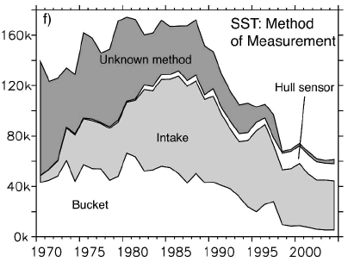
We have reanalysis data based on reconstructions from ships and buoys (subject to some of the same adjustment issues) and satellites. That data was removed by NOAA in July 2009 because of alleged “complaints” about a cold bias in the southern hemisphere. Immediately the result was a bump up of ocean and ocean/land global temperatures and the warmest ever July and August for the world’s oceans (of about 0.24C).

SUMMARY
The United States and global data bases have serious problems that render them highly questionable for determining accurate long term temperature trends. Especially since most of the issues mentioned produces a warm bias in the data.

As shown here, though there has clearly been some cyclical warming in recent decades (most notably 1979 to 1998), the global surface station based data is seriously compromised by urbanization and other local factors (land-use/land-cover, improper siting, station dropout, instrument changes unaccounted for and missing data) and uncertainties in ocean temperatures. Thus the data bases can’t be relied on to determine accurate trends. These factors all lead to overestimation of temperatures. Numerous peer-reviewed papers (referenced below in bold) in the last several years have shown this overestimation is the order of 30 to 50% from these issues alone.

See my and other relevant presentations and videos of some excellent keynote addresses at the Second Annual ICCC in New York City March 8-10, 2009 here.

References:

Block, A, Keuler, K., Schaller, E., 2004, Impacts of anthropogenic heat on regional climate patterns, Geophysical Research Letters, 31, L12211, DOI:10.1029/2004GL019852

Brohan, P., J.J. Kennedy, I. Harris, S.F.B. Tett and P.D. Jones, 2006: Uncertainty estimates in regional and global observed temperature changes: a new dataset from 1850. J. Geophysical Research 111, D12106, DOI:10.1029/2005JD006548

Davey, C.A., and R.A. Pielke Sr. (2005) “Microclimate Exposures of Surface-based Weather Stations - Implications for the Assessment of Long-term Temperature Trends.” Bulletin of the American Meteorological Society 86(4) 497–504

de Laat, A.T.J., and A.N. Maurellis (2006). “Evidence for Influence of Anthropogenic Surface Processes on Lower Tropospheric and Surface Temperature Trends.” International Journal of Climatology 26:897—913.
Easterling DR, Horton B, Jones PD, Peterson TC, Karl TR, Parker DE, Salinger MJ, Razuvayev V, Plummer N, Jamason P, Folland CK (1997) Maximum and minimum temperature trends for the globe. Science 277:364-367
Gall, R, Young, K., Schotland, R, Schmitz, J.: 1992. The Recent Maximum temperature Anomalies In Tucson. Are they real or an Instrument Problem, Journal of Climate, 5, 657-664.

Goodridge, JD (1996) Comments on "Regional Simulations of Greenhouse Warming including Natural Variability" . Bull, Amer. Meteorological Society 77:1588-1599

Hansen, J., Ruedy, R., Glascoe, J. and Sato, M. 1999. GISS analysis of surface temperature change. Journal of Geophysical Research 104: 30,997-31,022

Hansen, J, R. Ruedy, M. Sato, M. Imhoff, W. Lawrence, D. Easterling, T. Peterson, and T. Karl, 2001: A closer look at United States and global surface temperature change. Journal of geophysical research, 106 (D20), 23947-23963.

Hinkel, K.M., Nelson, F.E., Klene, S.E., Bell, J.H.:(2003). The Urban Heat Island In Winter At Barrow, Alaska, International Journal Of Climatology. 23: 1889–1905, DOI: 10.1002/joc.971
Jones, C.G., Young , K.C.,: )1995) An Investigation of Temperature Discontinuities Introduced by the Installation of the HO-83 Thermometer Journal of Climate Volume 8, Issue 5 (May 1995) pp. 1394
Jones PD, Groisman PYa, Coughlan M, Plummer N, Wangl WC, Karl TR (1990) Assessment of urbanization effects in time series of surface air temperatures over land. Nature 347:169-172

Jones, P. D., D. H. Lister, and Q. Li (2008), Urbanization effects in large-scale temperature records, with an emphasis on China, J. Geophys. Res., 113, D16122, doi:10.1029/2008JD009916.

Kalnay, E., Cai, M., Impacts of urbanization and land-use change on climate, 2003, Nature, 423, 528-531

Karl, T.R., H.F. Diaz, and G. Kukla, 1988: Urbanization: its detection and effect in the United States climate record, J. Climate, 1, 1099-1123
Karl, T.R, 1995: Critical issues for long-term climate monitoring. Climate Change, 31, 185.
Kent, E. C., S. D. Woodruff, and D. I. Berry. 2007. Metadata from WMO Publication No. 47 and an Assessment of Voluntary Observing Ship Observation Heights in ICOADS. Journal of Atmospheric and Oceanic Technology 24, no. 2: 214-234

Landsberg, H.E., 1981: The Urban Climate, Academic Press

Li, Q. et al., 2004: Urban Heat Island Effect on Annual Mean Temperatures during the
Last 50 Years in China. Theor. Appl. Climatol., 79, 165-174.

McKitrick, R.R. and P.J. Michaels (2007), Quantifying the influence of anthropogenic surface processes and inhomogeneities on gridded global climate data, J. Geophys. Res., 112, D24S09, doi:10.1029/2007JD008465.

McKitrick, R and P. J. Michaels (2004). “A Test of Corrections for Extraneous Signals in Gridded Surface Temperature Data” Climate Research 26(2) pp. 159-173. “Erratum,” Climate Research 27(3) 265—268.
Moberg, D. and A. 2003. Hemispheric and Large-Scale Air Temperature Variations: An Extensive Revision and Update to 2001. Journal of Climate, 16, 206-223.

Oke, T.R. 1973. City size and the urban heat island. Atmospheric Environment 7: 769-779.

Parker, D.E. (2004). “Climate: Large-Scale Warming is not Urban.” Nature 432, 290 (18 November 2004); DOI:10.1038/432290a

Peterson T.C. and R.S. Vose (1997) “An Overview of the Global Historical Climatology Network Temperature Database.” Bulletin of the American Meteorological Society 78:2837—2849.

Peterson, T.C. (2003). “Assessment of Urban Versus Rural in situ Surface Temperatures in the Contiguous United States: No Difference Found.” Journal of Climate 16(18) 2941—2959.

Peterson, 2006 Examination of potential biases in air temperature caused by poor station locations. Bull. Amer. Meteor. Soc., 87, 1073-1089

Pielke Sr., R.A., C. Davey, D. Niyogi, S. Fall, J. Steinweg-Woods, K. Hubbard, X. Lin, M. Cai, Y.-K. Lim, H. Li, J. Nielsen-Gammon, K. Gallo, R. Hale, R. Mahmood, S. Foster, R.T. McNider, and P. Blanken, 2007: Unresolved issues with the assessment of multi-decadal global land surface temperature trends. J. Geophys. Res., 112, D24S08, doi:10.1029/2006JD008229

Pielke Sr., R.A. J. Nielsen-Gammon, C. Davey, J. Angel, O. Bliss, N. Doesken, M. Cai., S. Fall, D. Niyogi, K. Gallo, R. Hale, K.G. Hubbard, X. Lin, H. Li, and S. Raman, 2007: Documentation of uncertainties and biases associated with surface temperature measurement sites for climate change assessment. Bull. Amer. Meteor. Soc., 88:6, 913- 928.

Runnalls, K.E. and Oke, T.R. 2006. A technique to detect microclimatic inhomogeneities in historical records of screen-level air temperature. Journal of Climate 19: 959-978.
Smith, T. M., and R. W. Reynolds (2004), Improved extended reconstruction of SST (1854-1997), J. Climate, 17, 2466-2477.
Smith, T. M., and R. W. Reynolds (2005), A global merged land air and sea surface temperature reconstruction based on historical observations (1880-1997), J. Climate, 18, 2021-2036
Zhou, L., Dickinson, R, Tian, Y., Fang, J, Qingziang, L., Kaufman, R, Myneni, R., Tucker, C., 2004, Rapid Urbanization warming China’s climate faster than other areas, Proceedings of the National Academy of Science, June 29, 2004

