US Temperatures and Climate Factors since 1895

The now familiar plot of the US climate network since 1895 shows a cyclical pattern with a rise from 1895 to a peak near 1930 and decline into the 1970s and then another rise with an apparent peak around 2000. Note the minor warming from the peak in 1930 to the peak in 2000.

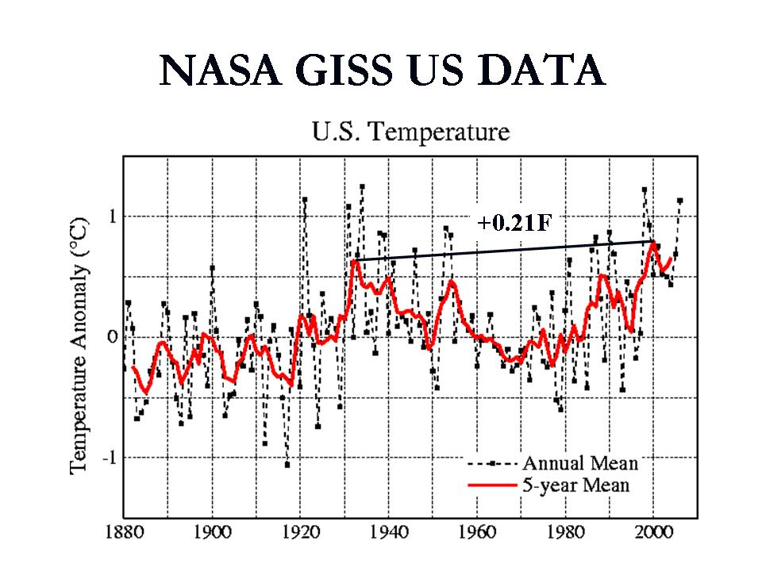

The short term fluctuations are driven by factors such as ENSO and volcanic eruptions. The longer term cycles are mainly driven by cycles in the sun and oceans although changes in the last half century have been increasingly blamed on anthropogenic factors.

Let’s look at the three factors mentioned and how well they correlate with the observed temperatures.

USHCN AND CARBON DIOXIDE
I first took the CDIAC annual mean carbon dioxide estimates since 1895 and plotted that against the annual USHCN. For a correlation, I did a 11 year smoothing to eliminate any effects of the 11 year solar cycle and to make it consistent with the other correlations. I got an r-squared of 0.29. Without that smoothing the correlation was 0.149.
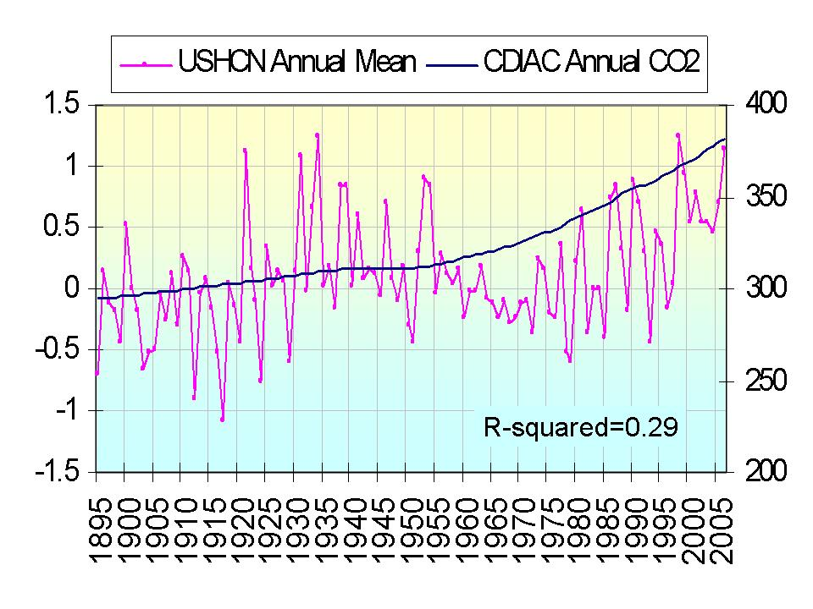
The USHCN Annual Mean temperatures plotted with the CO2 Annual Mean from CDIAC. The correlation was based on a smoothing of 11 years for consistency with the other correlations. An r-squared of 0.29 was found
USHCN AND SOLAR

The sun influences the climate in direct and indirect ways. A more active sun is a brighter slightly hotter sun and when the sun is hotter the earth is a little hotter. This small effect is magnified by other more indirect solar influences. When the sun is more active although its brightness (mainly visible light) only increases by 0.1%, the ultraviolet radiation increases by 6-8% and the even shorter wavelengths by a factor of two or more. These UV rays create and destroy ozone in the high atmosphere, both of which are exothermic effects and produce heat. Work by Labitzke and Shindell at NASA GISS have shown this to be important.

Shindell showed how this factor may have been responsible for the little ice age. When the sun is more active there are more flares and eruptive activity that causes rapid increases in the solar winds, causing ionization storms in the earth’s atmosphere with resultant heating. Also importantly an active sun causes the earth’s magnetic shield to block more cosmic rays from reaching into our atmosphere. Since these rays have a low water cloud formation enhancing effect (recently confirmed in the laboratory), an active sun usually means less low clouds and thus warmer temperatures. In all these cases, a more active sun brings warming.

Scafetta and West (2007) have suggested that the total solar irradiance (TSI) is a good proxy for the total solar effect which may be responsible for at least 50% of the warming since 1900.

I took the TSI from Hoyt Schatten and compared to the USHCN data (smoothing the data for 11 years to eliminate the 11 year solar cycle. I found a correlation strength (r-squared) of 0.64 lagging the temperatures 3 years after the solar. (Wigley and others have suggested a lag up to 5 years may be appropriate).

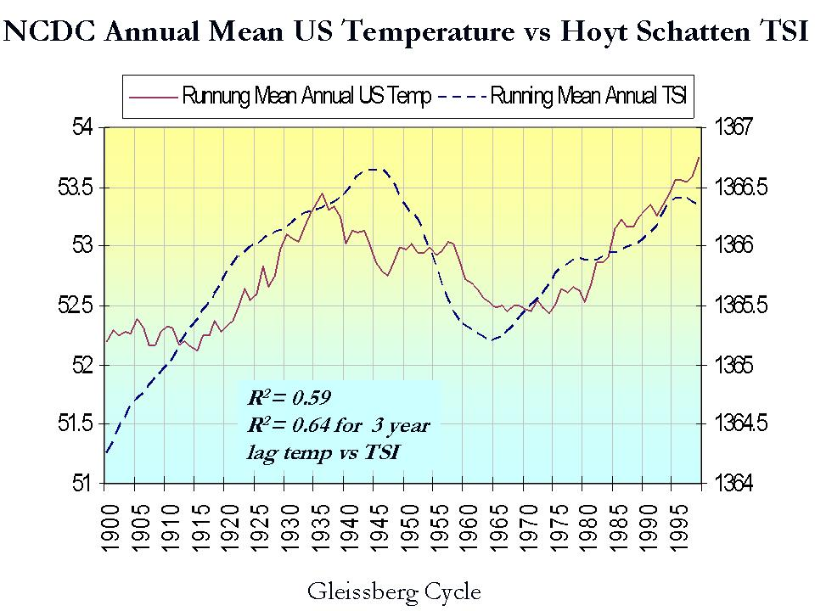

USHCN AND OCEAN MULITDECADAL CYCLES

We know both the Pacific and Atlantic undergo multidecadal cycles the order of 50 to 70 years. In the Pacific this cycle is called the Pacific Decadal Oscillation. A warm Pacific )positive PDO Index) as we found from 1922 to 1947 and again 1977 to 1997 is usually accompanied by more El Ninos while a cool Pacific more La Ninas (in both cases a frequency difference of close to a factor of 2). Since El Ninos have been shown to lead to global warming and La Ninas global cooling, this may have an affect on annual mean temperature trends in North America.

A similar mulitidecadal cycle exists in the Atlantic known as the Atlantic Multidecadal Oscillation (AMO). When the Atlantic is in its warm mode there tends to be more tropical activity and on average above normal temperatures on an annual basis across the northern hemispheric continents.
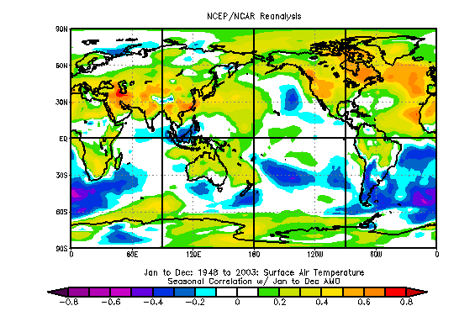

Since the warm modes of the PDO and AMO both favor warming and their cold modes cooling, I though the sum of the two may provide a useful index of ocean induced warming for the hemisphere (and US). I standardized the two data bases and summed them and correlated with the USHCN data, again using a 11 point smoothing as with the CO2 and TSI.

This was the jackpot correlation with the highest value of r-squared (0.86!!!).
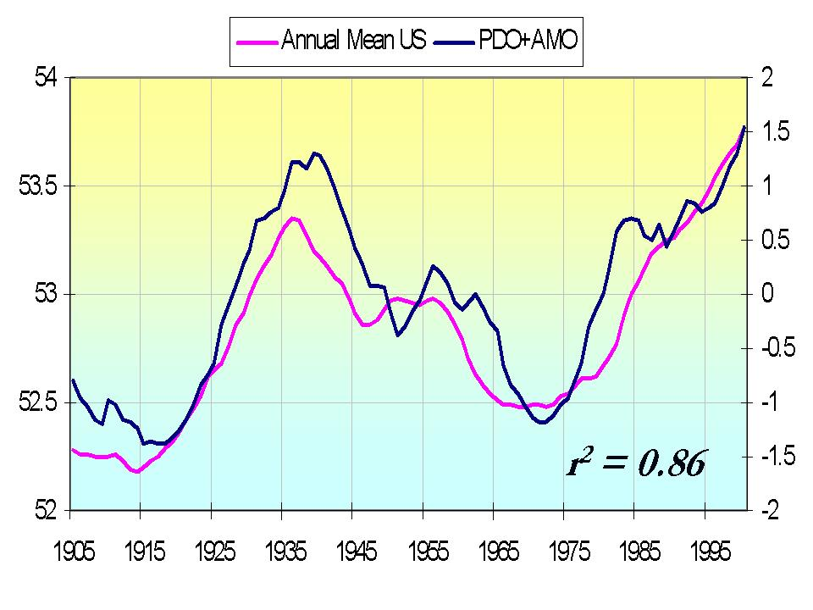
Note this data set started in 1905 because the PDO and AMO was only available from 1900.

THE LAST DECADE

Last week we showed how global satellite temperatures were uncorrelated with the monthly CO2 levels over the last decade (r-squared of just 0.07).

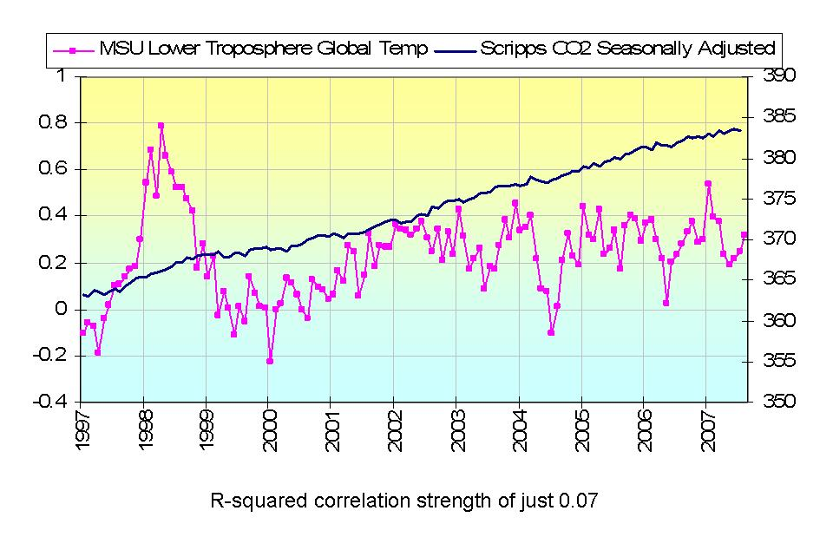
For USHCN and the CDIAC annual data, the correlation is even worse mover this time frame (0.05).

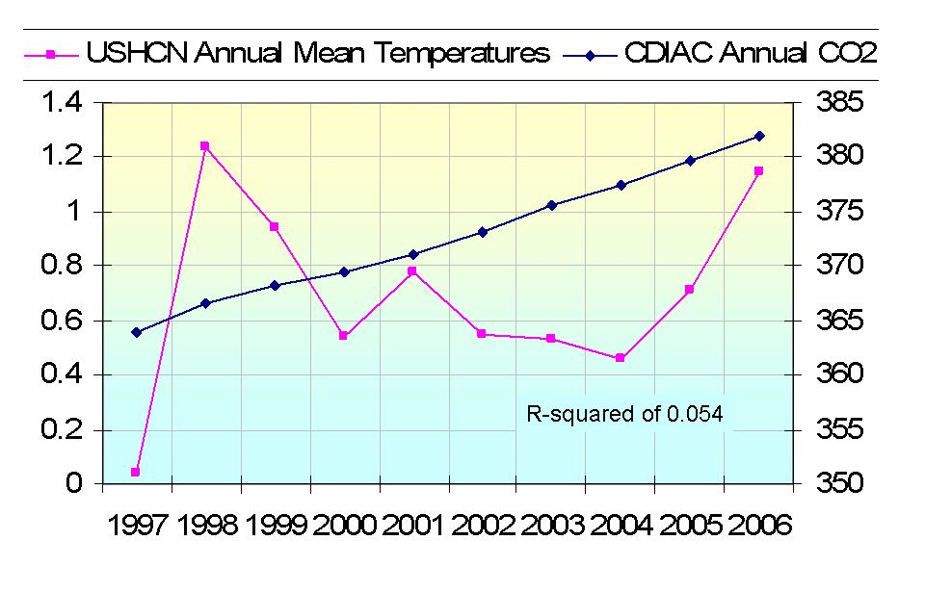
SUMMARY
USHCN temperatures show a cyclical behavior over the past 112 years with peak warming about 1930 and 2000. The temperature trends correlate with a number of factors. We examined them here. We found the correlation strengths to be as follows

Factor | Years | Correlation Strength (r-squared)
Carbon Dioxide | 1895-2006 | 0.29
Total Solar Irradiance | 1895-2005 | 0.64
Ocean Warming Index (PDO+AMO STD) | 1900-2006 | 0.86
Carbon Dioxide Last Decade | 1997-2006 | 0.05

Clearly the US annul temperatures over the last century have correlated far better with cycles in the sun and oceans than carbon dioxide. Whatsmore, this correlation with carbon dioxide seems to be weakening further in the last decade

Given the recent cooling of the Pacific and Atlantic and rapid decline in solar activity, we might anticipate given these correlations, temperatures to respond downwards shortly.

