A possible means of escape from
the horrors of carbon dioxide emission constraints

by
Richard S Courtney

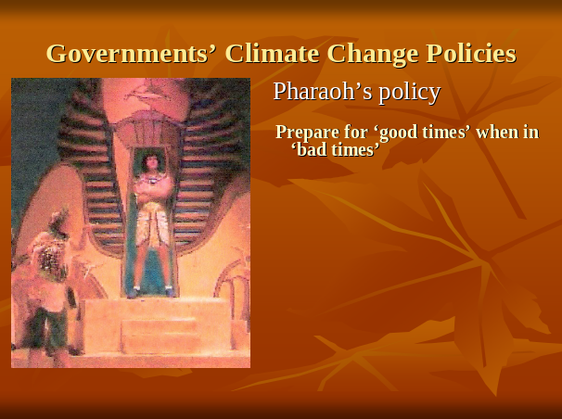
Friends:

Climate change is a serious problem and all governments – national and local – need to address it.

Climate has always changed everywhere and always will: this has been known since the Bronze Age when it was pointed out to Pharaoh by Joseph (the one with the Technicolour Dreamcoat). Joseph told Pharaoh to prepare for the bad times when in the good times, and all sensible governments have adopted that policy throughout the thousands of years since then.

That tried and tested policy is sensible because people merely complain at taxes in the good times, but they will revolt if they are short of food in the bad times.

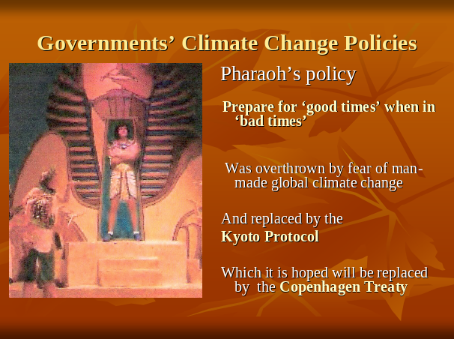

But in 1990 several governments decided to abandon that policy and, instead, to try to stabilize the climate of the entire Earth by controlling it. The UK started that policy and intends to continue it. Many governments of many countries are doing the same.

This attempt at global climate control arises from the hypothesis of anthropogenic (that is, man-made) global warming (AGW).

AGW does not pose a global crisis but the policy of attempted global climate control does.

AGW is a political issue. It is not a scientific issue.

AGW induced the ‘Earth Summit’ in Rio de Janeiro in 1992 and the Kyoto Summit in Japan in 1997. Both these events were attended by several Heads of State. And now we are confronted with CoP15; the fifteenth Conference of the nations that have signed the UN’s Framework Convention on Climate Change. CoP15 is to be held in Copenhagen in December and it, too, will be inundated by Heads of State.

Scientists attend scientific meetings. Politicians attend political meetings.

I will deal with what is likely to happen at Cop15 (which I call the No-Hope-In-Hagen Conference), but first I want to discuss AGW so we know what the real problem is.

AGW has become the State Religion in many paces, notably the European Union.



There may be some here who doubt AGW has become the State Religion. They need look no further than their television screens. The UK government is spending £6 million of our money on an advertisement that proclaims AGW is a horror story with which to frighten little children. According to that government advertisement, children are to be taught the future is not an opportunity for them to grow up into: it is a place of horrors where their pets are drowned and their homes are to be destroyed.

Teaching that to children is child abuse.

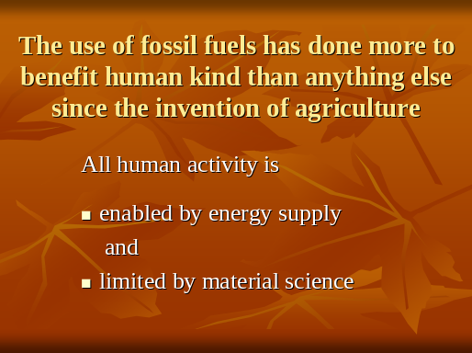

I repeat that AGW does not pose a global crisis but the policy of attempted global climate control does. And not merely because it is a tool to give children nightmares. The policy threatens constraint of the use of fossil fuels and that constraint would kill millions – probably billions – of people.

The use of fossil fuels has done more to benefit human kind than anything else since the invention of agriculture.

Most of us would not be here if it were not for the use of fossil fuels because all human activity is enabled by energy supply and limited by material science.

Energy supply enables the growing of crops, the making of tools and their use to mine for minerals, and to build, and to provide goods, and to provide services.

Material Science limits what can be done with the energy. A steel plough share is better than a wooden one. Ability to etch silica permits the making of acceptably reliable computers. And so on.

People die without energy and the ability to use it. They die because they lack food, or housing, or clothing to protect from the elements, or heating to survive cold, or cooling to survive heat, or medical provisions, or transport to move goods and services from where they are produced to where they are needed.

And people who lack energy are poor so they die from pollution, too.

For example, traffic pollution has been dramatically reduced by adoption of fossil fuels. On average each day in 1855 more than 50 tons of horse excrement was removed from only one street, Oxford Street in London. The mess, smell, insects and disease were awful everywhere. By 1900 every ceiling of every room in Britain had sticky paper hanging from it to catch the flies. Old buildings still have scrapers by their doors to remove some of the pollution from shoes before entering

Affluence reduces pollution. Rich people can afford sewers, toilets, clean drinking water and clean air. Poor people have more important things they must spend all they have to get. So, people with wealth can afford to reduce pollution but others cannot. Pollution in North America and Europe was greater in 1900 than in 2000 despite much larger populations in 2000. And the pollution now experienced every day by billions who do not have the wealth of Americans and Europeans includes cooking in a mud hut using wood and dung as fuel when they cannot afford a chimney.

The use of fossil fuels has provided that affluence for the developed world. The developing world needs the affluence provided by the development which is only possible at present by using fossil fuels.

We gained our wealth and our population by means of that use.

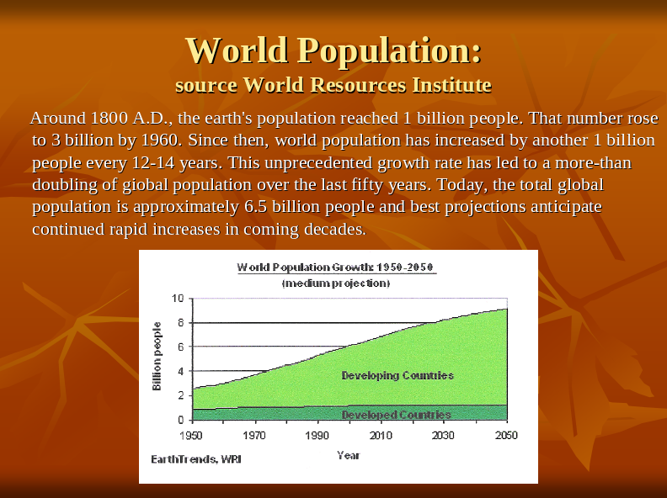

The energy supply increased immensely when the greater energy intensity in fossil fuels became available by use of the steam engine. Animal power, wind power and solar power were abandoned because the laws of physics do not allow them to provide as much energy as can be easily obtained from using fossil fuels.

The greater energy supply enabled more people to live and the human population exploded. Our population has now reached about 6.6 billion and it is still rising. All estimates are that the human population will peak at about 9 billion people near the middle of this century.

That additional more than 2 billion people in the next few decades needs additional energy supply to survive. The only methods to provide that additional energy supply at present are nuclear power and fossil fuels. And the use of nuclear power is limited because some activities are difficult to achieve by getting energy from the end of a wire.

If anybody here doubts this then I tell them to ask a farmer what his production would be if he had to replace his tractor with a horse or a Sinclair C5.

So, holding the use of fossil fuels at its present level would kill at least 2 billion people, mostly children. And reducing the use of fossil fuels would kill more millions, possibly billions.

That is not an opinion. It is not a prediction. It is not a projection. It is a certain and undeniable fact. Holding the use of fossil fuels at their present levels would kill billions of people, mostly children. Reducing the use of fossil fuels would kill more millions or billions.

Improving energy efficiency will not solve that because it has been known since the nineteenth century that improved energy efficiency increases energy use: as many subsequent studies have confirmed.

So, in a period of a few decades we have moved from the tried and tested climate policy that has stood the test of time since the Bronze Age, and we have replaced it with quasi-religious political madness which – if not stopped – will pale into insignificance the combined activities of Ghengis Khan, Adolf Hitler and Pol Pot.

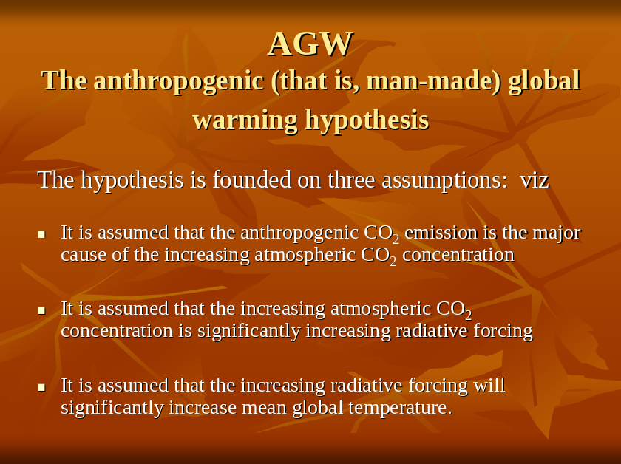

How did we get into this mess? It came about because governments have adopted the AGW hypothesis.

But that hypothesis always was implausible and it is now known to be wrong.

The AGW-hypothesis says increased greenhouse gases – notably carbon dioxide (CO₂) – in the air raise global temperature, and anthropogenic emissions of carbon dioxide are increasing the carbon dioxide in the air to overwhelm the natural climate system.

The hypothesis is founded on three assumptions: viz

(1) It is assumed that the anthropogenic CO₂ emission is the major cause of the increasing atmospheric CO₂ concentration
and
(2) It is assumed that the increasing atmospheric CO₂ concentration is significantly increasing radiative forcing
and
(3) It is assumed that the increasing radiative forcing will significantly increase mean global temperature.

There are reasons to doubt each of these assumptions. But if any one of them were known to be false then the entire AGW hypothesis would be known to be false.

Think about it.

The hypothesis is that a trace atmospheric gas which is the very stuff of life itself may – if it increases its atmospheric concentration – become Shiva, the Destroyer of Worlds. In fact, it’s worse than that. Nature emits 34 molecules of CO₂ for every molecule of CO₂ emitted by human activities so AGW suggests that a minute increase to the annual emission of this essential trace gas could cause Armageddon. Furthermore, in the geological past and during ice ages the atmospheric CO₂ concentration has been more than ten times greater than it is now.

If you had never heard of AGW and somebody came in off the street and tried to sell it to you would you say, “Oh dear! Of course, we must change the economic activity of the entire world”?

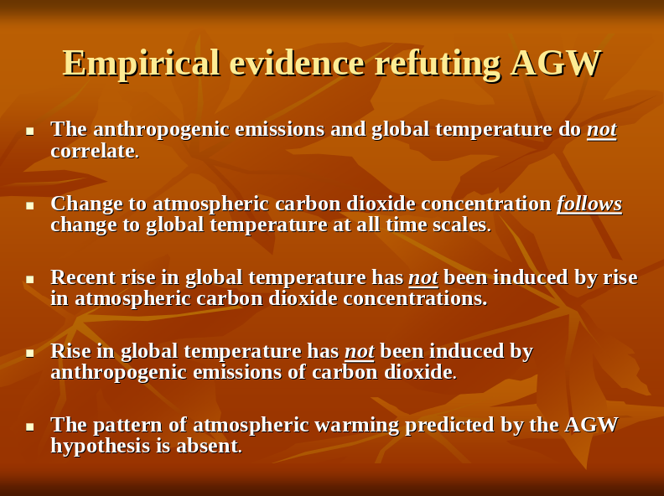

But, implausible things do exist so we need to check the AGW hypothesis against reality.

Empirical evidence says the hypothesis is wrong.

1. The anthropogenic emissions and global temperature do not correlate.

2. Change to atmospheric carbon dioxide concentration follows change to global temperature at all time scales.

3. Recent rise in global temperature has not been induced by rise in atmospheric carbon dioxide concentrations.
Global temperature fell from 1940 to 1970, rose to 1998, and has fallen since. That’s 40 years of cooling and 28 years of warming. Global temperature is now similar to that of 1990. But atmospheric carbon dioxide concentration has increased at a near constant rate and by more than 30% since 1940. It has increased by 8% since 1990.

4. Rise in global temperature has not been induced by anthropogenic emissions of carbon dioxide.
Over 80% of the emissions have been since 1940 and the emissions have been increasing at a compound rate. But since 1940 there have been 40 years of cooling with only 28 years of warming. There’s been no significant warming since 1995, and global temperature has fallen since the high it had 10 years ago.

5. The pattern of atmospheric warming predicted by the AGW hypothesis is absent.
The hypothesis predicts most warming of the air at altitude in the tropics. Measurements from weather balloons and from satellites both show cooling at altitude in the tropics.

So, the normal rules of science say the AGW-hypothesis is completely refuted.
Nothing the hypothesis predicts is observed, and the opposite of some of its predictions are observed.

But some people promote the hypothesis. They’ve several reasons (personal financial gain, protection of their career histories and futures, political opportunism, and…). But support of science cannot be one such motive because science denies the hypothesis. So, additional scientific information cannot displace the AGW-hypothesis and cannot silence its advocates. And those advocates are not scientists despite some of them claiming they are.

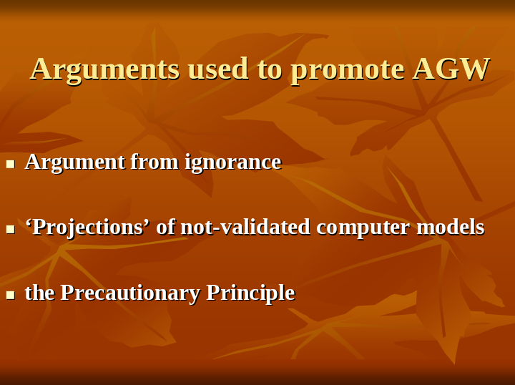

Advocates promote AGW using three kinds of pseudo-science.

They use ‘argument from ignorance’. This isn’t new. In the Middle Ages experts said, “We don’t know what causes crops to fail: it must be witches: we must eliminate them.” Now, experts say, “We don’t know what causes global climate change: it must be emissions from human activity: we must eliminate them.” Of course, they phrase it differently saying they can’t match historical climate change with known climate mechanisms unless an anthropogenic effect is included. But evidence for this “anthropogenic effect” is no more than the evidence for witches.

Advocates rely on not-validated computer models.
No model’s predictions should be trusted unless the model has demonstrated forecasting skill. But climate models have not existed for 20, 50 or 100 years, so they cannot have demonstrated forecasting skill.

Simply, the climate models’ predictions of the future have the same demonstrated reliability as the casting of chicken bones to predict the future.

Advocates use the Precutionary Principle saying we should stop greenhouse gas emissions in case the AGW hypothesis is right. But that turns the Principle on its head.

Stopping the emissions would reduce fossil fuel usage with resulting economic damage. This would be worse than the ‘oil crisis’ of the 1970s because the reduction would be greater, would be permanent, and energy use has increased since then. The economic disruption would be world-wide. Major effects would be in the developed world because it has the largest economies. Worst effects would be on the world’s poorest peoples: people near starvation are starved by it.

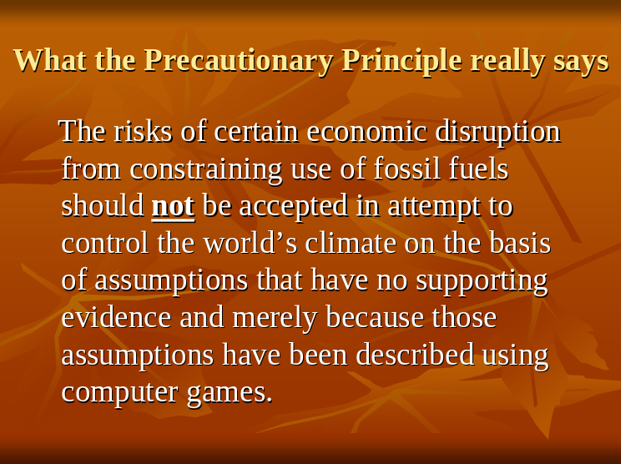

The precautionary principle says we should not accept the risks of certain economic disruption in attempt to control the world’s climate on the basis of assumptions that have no supporting evidence and merely because they’ve been described using computer games.

So, AGW is not a global crisis but the unfounded fear of AGW is. It threatens a constraint of fossil fuel use that would kill millions – probably billions – of people.

This begs the questions as to why governments care about AGW and what is likely to happen at the No-Hope-in-Hagen Conference?

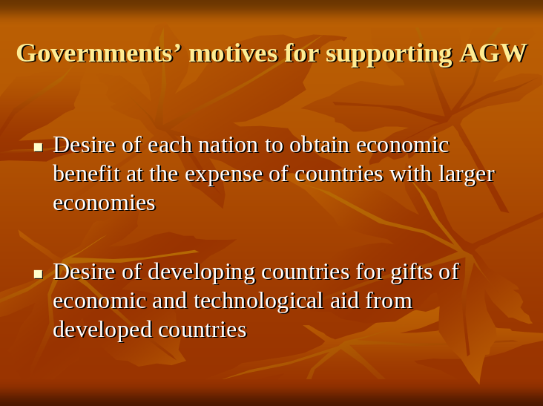

Governments have a variety of motives for interest AGW. Each has its own special interests in AGW but, in all cases, the motives relate to economic policies. In general, the USA fears loss of economic power to other nations while this is desired by those other nations. Universal adoption of ‘carbon taxes’, or other universal proportionate reductions in industrial activity, would provide relative benefit to the other nations.

Developing nations cannot afford technological and economic advances that would benefit them and also reduce their increases to CO₂ emissions as they develop, so they are seeking gifted technology transfers and economic aid from developed countries.

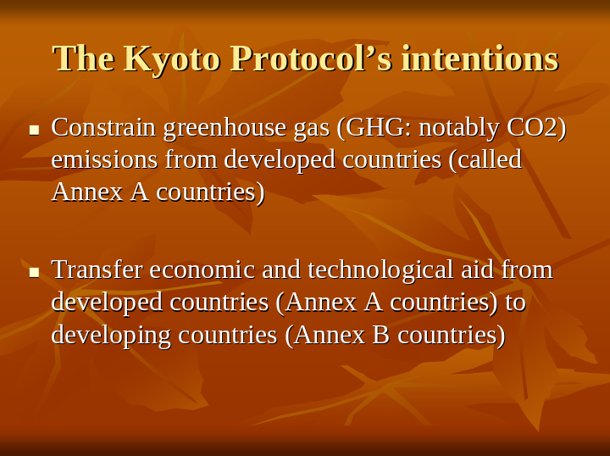

The Kyoto Protocol was an attempt to meet these desires. It is an international Treaty that will run-out in 2012 and the No-Hope-In-Hagen Conference is an attempt to agree a successor to it. The Kyoto Protocol set limits to emissions of 6 greenhouse gases (notably CO₂) from developed countries, and it promotes transfer of technology and economic activity to developing countries.

This may seem innocuous, but it is a real Treaty in the real world that is intended to address a hypothetical threat. Nothing costs nothing in the real world.

The Kyoto Protocol is a very expensive. It has been estimated that every man, woman and child on Earth could be supplied with clean drinking water and mains sewers for less than a tenth of the cost of the Kyoto Protocol if it were implemented.

Fortunately, nobody has really tried to abide by it.

But, unfortunately, several countries – and notably the EU – have pretended to be working towards its objectives by introducing ‘Carbon Trading’ schemes of various kinds.

Please note that this really is money for hot air. Carbon Trading markets are the only markets where both the buyers and the sellers are paid to lie. Corruption is a ‘built-in’, and we are already getting people prosecuted for fraud in the EU scheme. The Mafia would have been hard-pressed to suggest a system like this.

The Kyoto Protocol only applied to developed countries and the developed countries want developing countries to be bound by the successor Treaty.

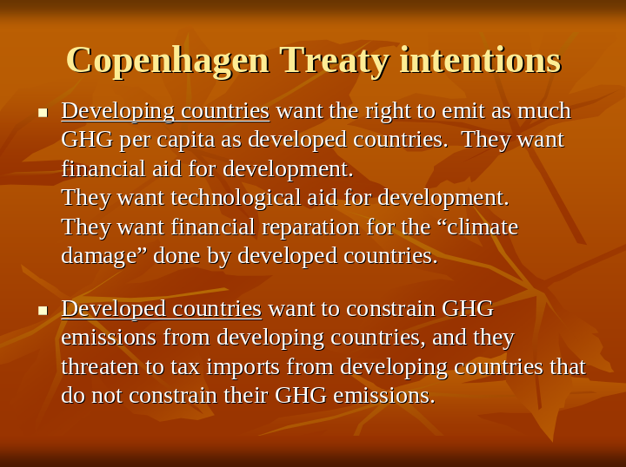

The developing countries say they are entitled to make the same per capita emissions as developed countries. China and India are classed as developing countries under the Kyoto Protocol. China emits more CO₂ emissions than any other country and says it will stop increasing its emissions when it achieves the same per capita emissions as the West. India says the same.

Indeed, the developing countries want payments from developed countries as reparations for the damage done to climate by the developing countries.

Simply, developing countries are using AGW as an excuse for aid from developed countries and are pushing this as their line for the proposed No-Hope-in-Hagen Treaty.

But developed countries are using ‘Carbon Trading’ schemes as their proposals for what is to be required of them while demanding constraints on emissions from developing countries. And they are using AGW as excuses for taxation at home. Importantly, they are using AGW as an excuse for protectionism by trying to get the No-Hope-in-Hagen Treaty to constrain economic development in developing countries.

The desires of developing and developed countries for the Treaty are directly opposed and the negotiations are deadlocked. But something will come out of No-Hope-in-Hagen because it has to. That is the nature of politics.

The problem is that whatever results from No-Hope-in-Hagen will be harmful to the people of the world.

So, what alternative could be championed?

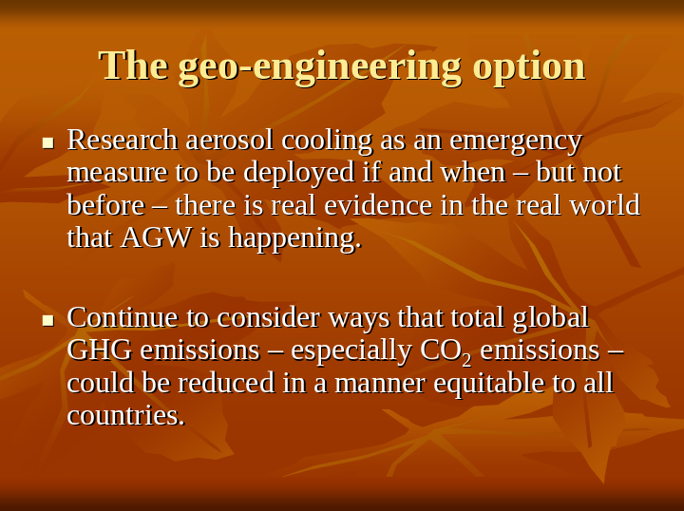

At present there is no empirical evidence of any kind that the AGW hypothesis is correct. But supporters of the AGW-scare assert that action must be taken now to avoid the possibility of dangerous AGW in the future.

Politicians are responding to the AGW-scare by trying to constrain anthropogenic emissions of greenhouse gases (GHGs), notably carbon dioxide (CO₂). Such constraints would do much harm and, therefore, they should not be accepted unless absolutely necessary. But politicians of several countries are committed to their having accepted the AGW-scare as being a potential threat which warrants the constraints.

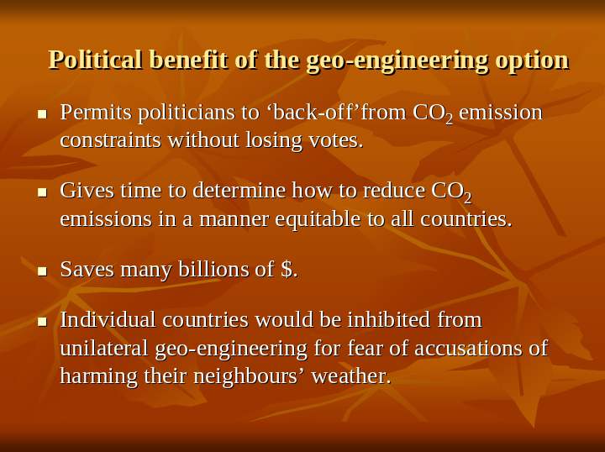

The politicians need a viable reason if they are to back-off from this commitment to the constraints without losing face.

They cannot say they were wrong to have supported AGW because that would lose them votes.

And they cannot be seen to be doing nothing in response to the AGW scare because that would lose them votes.

They need to be seen to be doing something while really doing nothing unless and until something needs to be done. And a rapid response to an observed problem of AGW is needed.

The geo-engineering option provides the needed viable reason to do nothing about AGW now.

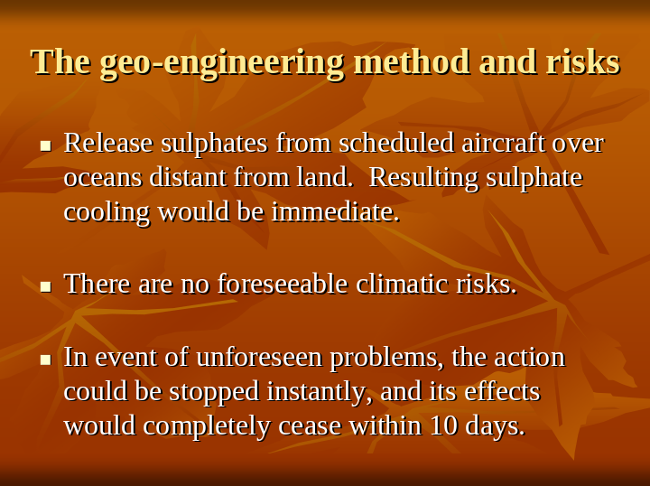

The AGW-scare is founded on an unproven assumption that global temperature is determined by net radiative forcing, and increase to greenhouse gases in the air provides additional positive radiative forcing.

Increase to aerosols in the air increases cloud cover to provide additional negative radiative forcing. So, increasing atmospheric aerosols would drop global temperature. And this could be done at relatively little cost, for example, by emitting sulphates from commercial aircraft.

Hence, if AGW does prove to be a problem then the geo-engineering is a method to immediately stop its effects when it is detected. Actions to constrain the GHG emissions could then be implemented. The cost of the geo-engineering would be much less than the costs of the constraints to GHG emissions in the period until effects of AGW are detected. Indeed, the costs of the geo-engineering would be trivial compared to the costs of 20% reduction to world-wide GHG emissions for a single year.

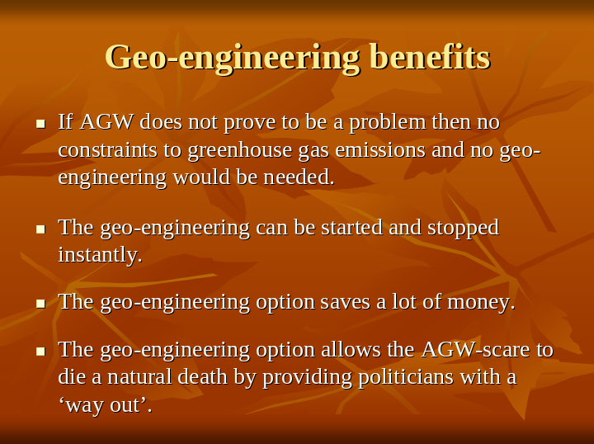

Importantly, very importantly, if AGW does not prove to be a problem then no constraints to greenhouse gas emissions and no geo-engineering would be needed.

In the extremely improbable event that the geo-engineering were needed then it would have very little risk because aerosols wash out of the air in a few days so the geo-engineering and its effects could be stopped instantly in the event that it were to cause a problem. And no such problem is foreseeable.

Whether or not AGW does become a real problem in the real world, the geo-engineering option is preferable to adopting constraints on GHG emissions in the near future.

And politicians could be seen to be doing something by implementing geo-engineering trials with press publicity and with photo-shoots while continuing to talk about how to constrain CO₂ emissions should such constraints ever become needed.

This suggested political ploy is not fanciful and it has precedent. Opponents of the nuclear industry have objected that there is no “safe” method to dispose of nuclear waste. And the nuclear industry has responded by asserting that the waste could be vitrified. A practical method for the vitrification still remains to be developed, but assertion of the possibility of the vitrification has been sufficient to overcome objections to nuclear power in several countries for nearly 40 years. (Incidentally, I am in favour of nuclear power).

So, I call for a return to sanity. And I call for health, wealth and prosperity for all humankind.

Thankyou.



